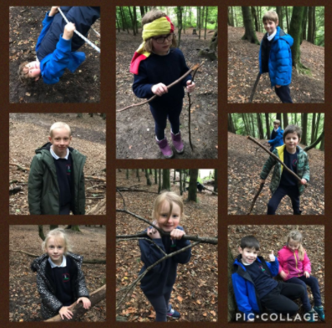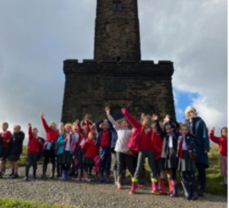
Welcome to Beech Class, Year 3 & 4
Useful information to know about Beech Class
Staffing
Your class teachers are Mrs Longstaff and Mrs Thomond.
Mrs Longstaff will be teaching the class in the mornings on Monday, Tuesday and Wednesday, as well as all day Thursday and Friday. Mrs Thomond will teach in the afternoons on Monday, Tuesday and Wednesday. The children will also work with our Teaching Assistants: Mrs Brewer and Mrs Hughes. All of the staff are very excited about planning lots of exciting activities and trips!
In Class
The children are encouraged to bring a water bottle to have in class (no juice) – please ensure they are labelled clearly. They are not provided with free fruit as they were in KS1, so we encourage the children to bring a healthy snack of either; fresh fruit, fresh vegetables, plain popcorn, plain breadsticks, plain crackers, or plain rice cakes. No nuts, peas or sesame please!
There is limited space in the classroom so no large bags – a book bag is perfect! For children in KS2 we offer a different design of school bag. The bags are available at a cost of £6.50 and can be bought online by making a payment to Bury Council. We would strongly encourage the children in KS2 to use this design of bag.
Children don’t need any stationary, e.g. pencil cases, notebooks, as everything is provided. However, when children are in Year 4, they move from pencil to pen. School will provide a blue biro pen, however, if parents are able to purchase a blue ‘Pilot Frixion’ pen and refills (pictured below), then that would be hugely helpful. These pens encourage clean, smooth writing and offer the advantage of an eraser on the end of the pen. Unfortunately, this is something the school budget cannot accommodate.
Sensory Toys
Every class has a basket of sensory aids, that are accessible to all children. Please do not send your child into school with a fidget toy or sensory aid, as these can easily get lost.
Birthdays
We politely request that you do not send in sweets or cakes for birthdays. Instead we suggest donating a book or game for the class. Birthday certificates are stuck into books that are donated.
Mental Maths
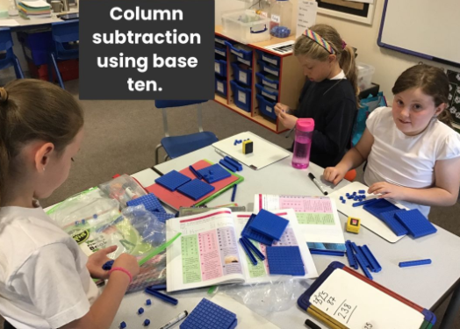
It is essential that the children continue to practise and become proficient in mental skills. This includes telling the time, knowing number bonds, times tables and being able to use known facts to help complete calculations. By the end of Year 3, children should know their 2, 3, 4, 5, 8 & 10 tables. By the end of Year 4, children should know all times tables. Please continue to work with your child to help them become, and remain, fluent in these skills. We are sending home a times tables booklet, so that your child can practise over the summer.

Reading
The children will not be heard individually in school as often as they were in KS1, although some children will be identified and supported as daily readers. Reading within Beech Class will be taught through guided reading groups and follow-up tasks will be set on Seesaw. As part of guided reading sessions, children discuss their individual reading books every month.
It is essential that the children continue to read with parents at home daily and that children have the opportunity of discussing their reading with someone. Reading books will be changed by the children when they have finished a book. Please fill in the Reading Record as you did in KS1, to tell us how far they have read, if they had any difficulties and whether or not they understood the book. Please ensure your child has their guided reading and individual reading book in school every day.
Summer Reading
We will be sending your child home with three reading books to read over the summer holidays. We will upload a photograph of your child with their three books to Seesaw. Please return these books in September. Lost or damaged books will be charged at £5.00 per book.

Handwriting
Our expectation is that all children by the end of Year 3 will have a cursive style of writing and will be given a pen in Year 4.
Homework
Every Friday on the Seesaw Journal, there will be a Google Classroom slide with links to the following: Maths Basic Skills, Grammar Hammers and 5 weekly spellings from the Y3 and 4 statutory spelling list. In addition, a guided reading task will be set weekly as an activity on Seesaw. We would also like the children to read daily and practise their times tables.
PE
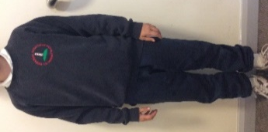
In KS2 the children have 2 sessions of PE a week and wear their ‘Blue Uniform’. This consists of a white t-shirt, blue joggers, blue sweatshirt (not a hoody) and trainers. If you would like more information about this sports uniform please speak with the office. On the days when the children do PE they will come to school in the sports uniform and wear it all day. Blues days in Beech Class are Tuesday and Thursday. The children do not need a PE kit to leave in school.

Uniform
We have high expectations for uniform, and we do not allow logos on clothes or nail varnish. Please ensure long hair is tied up. Children are allowed to wear stud earrings and a watch if they wish.
We will be going off site regularly, therefore please ensure your child has one pair of wellingtons, a waterproof coat and trousers (all named).

Punctuality
Every morning from 8.45am, an early morning activity is set. This will be handwriting, daily reading, maths fluency or catch-up interventions. It would be really helpful if your child was in the classroom for 8.45am, ready to learn.

Communication
Any messages regarding well-being or learning can be sent through Seesaw to Mrs Longstaff or Mrs Thomond. All other messages need to be sent through the school office e.g. absences, medical appointment, collecting your child early.
In September you will be invited to a ‘Meet the Teacher’ and Hadrian’s Wall Residential information evening in school, (COVID guidance permitting.) This will be held remotely if necessary.
A Final word…
We are really looking forward to welcoming the children into Beech Class on Thursday 2nd September. If you have any questions please do not hesitate to ask. Have a lovely Summer!

