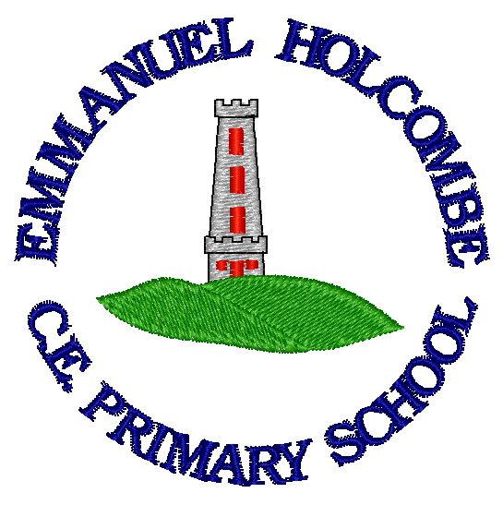

Emmanuel Holcombe C of E Primary
Physical Education curriculum

2020

Emmanuel Holcombe long term PE curriculum

Emmanuel Holcombe School develops the PE curriculum with input from other external companies and schemes. The curriculum is skills led, with target statements provided at three key points within the school. In conjunction with this we also follow the Commando Joe scheme of work.

Intent
The intention of the PE curriculum at Emmanuel Holcombe is that children are taught to develop an interest in physical activity and sports. Lessons are designed to enjoyable and stimulating. We encourage the children to build their skills and confidence. We strive to embed the skills of athletics, gymnastics, dance and team games. It is our aim that all the children have the opportunity to take part in a range of sporting activities. They will be given the chance to represent the school and become a member of an after-school clubs.

Implementation

The Emmanuel Holcombe curriculum is shaped by the school vision to enable all children, regardless of background, ability or additional needs to flourish and live life to the full. Our PE curriculum has been designed in line with the National Curriculum (2014), to produce clear skills and knowledge progression.

The teaching of Physical Education will be carried out using a two-year cycle. Each half term the children will be given a different topic. e.g. Gymnastics
At Emmanuel Holcombe Primary School, with aim to deliver two hours of high quality PE per week which is inline with government guidelines.
KS1 |  |  | KS2
REC | Y1 | Y2 | Y3 | Y4 | Y5 | Y6
90 | 120 | 120 | 120 | 120 | 120 | 120
For relevant year groups the times above include swimming sessions.

PE sessions are matched to the main hall timetable. Dependent on the activity, the staff will decide whether the session will be taught inside or outdoors. Whenever possible the staff will try to take the children outside.
What do we use?
- Primarily we use the Twinkl Move scheme of work.
- The Commando Joe’s scheme is used to build resilience, teamwork and develop a range of skills.

Impact
Our PE curriculum will ensure all pupils develop key learning skills, as set out by the national curriculum. These are as follow:
- develop competence to excel in a broad range of physical activities
- are physically active for sustained periods of time
- engage in competitive sports and activities
- lead healthy, active lives.

What the National Curriculum says:

Key Stage 1 | Key Stage 2
Pupils should develop fundamental movement skills, becoming increasingly competent and confident and access a broad range of opportunities to extend their agility, balance and coordination, individually and with others. They should be able to engage in competitive and co-operative physical activities, in a range of increasingly challenging situations.  Pupils should be taught:  - Master basic movements including running, jumping throwing and catching, as well as developing balance, agility and co-ordination, and begin to apply these in a range of activities.  - Participate in team games, developing simple tactics for attacking and defending.  - Perform dances using simple movements. | Pupils should continue to apply and develop a broader range of skills, learning how to use them in different ways and ink them to make actions and sequence movements. They should enjoy communicating, collaborating and competing with each other. They should develop an understanding of how to improve in different physical activities and sports and learn how to evaluate and recognise their own success.  Pupils should be taught to:  - Use running, jumping, throwing and catching in isolation and combination.  - Play competitive games, modified where appropriate, and apply basic principles suitable for attacking and defending.  - Develop flexibility, strength, technique, control and balance.  - Perform dances using a range of movement patterns.  - Take part in outdoor and adventurous activity challenges both individually and within a team.  - Compare their performance with previous ones and demonstrate improvement to achieve their personal best.

Each of the following skills are linked to the PE Curriculum, by the end of each phase the children will have had the opportunity of mastering the following techniques.
 | By the end of KS1 children will: | By the end of Year 4 children will: | By the end of KS2 children will:
Games | - Develop individual and team skills through a focus on agility, balance and co-ordination.  - Focus on throwing and catching skills.  - Learn the fundamentals of Hockey, Tag Rugby and Basketball. | - Developing agility, balance and co-ordination.  - Be introduced to and begin to understand the rules of Hockey, Tag Rugby, Basketball and Rounders.  - Play Hockey, Tag Rugby, Basketball and Rounders whilst following the rules. | - Developing agility, balance and co-ordination.  - Play and embed their understand of the rules of Hockey, Tag Rugby, Basketball, Rounders, and Football.
Dance | - Develop dance skills and dances related to the class topics.  - Begin to understand what a rhythm is.  - Begin to match movement to a piece of music. | - Develop dance skills and dances linked to the topic.  - Develop rhythm and timing. | - Develop a repertoire of dance skills.
Gymnastics | - Develop their travelling, stretching and curling.  - Be able to support and transfer weight.  - Think carefully about their body shape.  - Develop linking movements.  - Work with a partner to carry out gymnastic skills. | - Develop their travelling, stretching and curling.  - Be able to support and transfer weight.  - Think carefully about their body shape.  - Develop linking movements.  - Work with a partner to carry out gymnastic skills. | - Develop their sense of balance.  - Be able to work effective with a partner.  - Look at the skills of symmetry and asymmetry.
Athletics | - Understand the basics of running.  - Understand the difference between sprinting and long-distance running.  - Learn the difference between the underhand and overarm throw.  - Effectively carry out a standing jump.  - Understand how to land from a jump safely and effectively. | - Develop the techniques of running.  - Develop the skill of jumping.  - Understand how to effectively run and jump.  - Develop the skill of throwing.  - Understand the correct stance and grip to throw a javelin.  - Understand that we pass the baton in a relay race.  - Learn an effective method of passing the baton during a relay race.  - Understand they need to jump and how to effectively jump in a hurdles races. | - Develop the techniques of running, jumping and throwing, hurdles and relay.  - Begin to jump using the triple jump method.
Swimming |  | - Swim confidently and proficiently over 25 metres.  - Use a range of strokes effectively.  - Perform safe self-rescue in different water-based situations. | - Swim confidently and proficiently over 25 metres.  - Use a range of strokes effectively.  - Perform safe self-rescue in different water-based situations.

Resources
Outside PE Cupboard | - Rugby Balls  - Basket Balls/Netballs  - Wooden Hockey Sticks  - Plastic Hockey Sticks  - Rounders Poles and Bases  - Rounders Bats  - Large Rubber Balls  - Running Ladders  - Javelins  - Cricket Stumps  - Cricket Bats  - Cricket Balls  - Large Net  - Tennis Rackets  - Metal Hurdles  - Plastic Hurdles  - Long Jump Mats
PE Trolley | - Tag Rugby Belts  - Tennis Balls  - Plastic Balls  - Skipping Ropes  - Bean Bags  - Rubber Rings  - Sponge Balls  - Table Tennis Nets  - Table Tennis Paddles  - Table Tennis Balls  - Plastic Cones  - Boules  - Hoops  - Ball Pumps and Needles  - Coloured Bibs

Curriculum Overview
PE School Overview Year A
Class | Autumn 1 | Autumn 2 | Spring 1 | Spring 2 | Summer 1 | Summer 2
1 |  | Fundamental Skills (Christmas) | Gymnastics  (Jumping Jacks and Rock and Roll) | Fundamental Skills (Easter) | Dance  (Dinosaurs) | Invasion Games (Best of Balls)
2 | Gymnastics (Animals) | Invasion Games  (Y2 Unit) | Dance  (Starry Skies) | Athletics  (Multi-Skills) | Gymnastics (Traditional Tales) | Invasion Games  (Throwing and Catching)
3 | Gymnastics (Movement Y3) | Invasion Games (Rugby) | Dance  (Romans) | Athletics  (Y4 Unit) | Gymnastics  (Movement Y4) | Invasion Games (Hockey)
4 | Gymnastics (Movement Y5) | Invasion Games  (Basketball) | Dance  (Haka) | Athletics  (Y5 Unit) | Gymnastics | Invasion Games  (Netball)

PE School Overview Year B
Class | Autumn 1 | Autumn 2 | Spring 1 | Spring 2 | Summer 1 | Summer 2
 |  | Fundamental Skills (Christmas) | Gymnastics  (Jumping Jacks and Rock and Roll) | Fundamental Skills (Easter) | Dance  (Dinosaurs) | Invasion Games (Best of Balls)
2 | Athletics  (Running and Jumping) | Dance  (Toys) | Gymnastics (Landscapes and Cityscapes) | Invasion Games (Attacking and Defending) | Dance  (The Seasons) | Athletics  (Multi-Skill)
3 | Athletics  (Y3 Unit) | Dance  (Extreme Earth or Water) | Gymnastics (Shape) | Invasion Games (Striking and Fielding) | Dance  (Carnival of the Animals) | Outdoor Adventures
4 | Athletics  (Y6 Unit) | Dance  (WWII) | Gymnastics  (Movement Y6) | Invasion Games  (Striking and Fielding Rounders) | Dance (Electricity) | Outdoor Adventures

