Emmanuel Holcombe Science policy

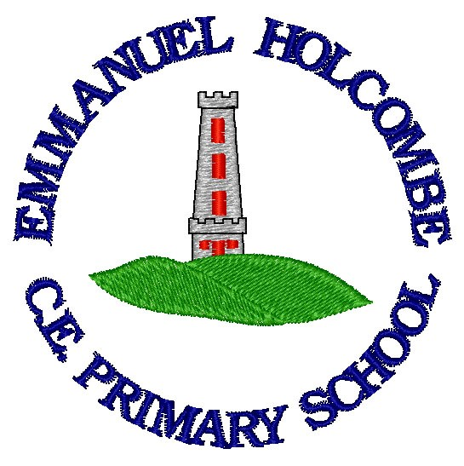

Date of Policy: July 2019 Date of Review: July 2020

Vision Statement
Jesus came to give us life in all its fullness. Our vision is that through faith, family and friendship, each of us can grow in love and learning, being tolerant, having resilience and developing enquiring minds, so that we can all experience the abundance Jesus came to give us.
Rationale
Science allows the children the opportunity to explore and understand the world in which they live. Science at Emmanuel Holcombe should give the children the tools to improve their ideas and knowledge. It should enable them to understand the world through investigation developing their independence, resilience and enjoyment.

Aims and Targets
- To prepare our children for life in an increasingly scientific and technological world.
- To foster care and concern for our environment.
- To help our children acquire a growing understanding of scientific ideas.
- To help develop and extend our children’s knowledge of scientific concepts.
Attitudes
- To encourage the development of resilience and positive attitude towards science.
- To build on our children’s natural curiosity and develop their scientific approaches to problems.
- To encourage open mindedness, self-assessment, perseverance and responsibility.
- To build the children’s self-confidence, allowing them to work independently.
- To develop our children’s social skills and teamwork.
- To provide our children with an enjoyable experience of science, so that they will develop a deep and lasting interest in science.
Skills
- To give our children an understanding of scientific processes.
- To help our children acquire practical scientific skills.
- To develop the skills of investigation – Including observation, measuring, predicting, hypothesising, experimenting, communicating, interpreting, explaining and evaluating.
- To develop the children’s use and understanding of scientific vocabulary.
- To enable our children to become effective communicators of scientific ideas, facts and data.
- To enable our children to work scientifically and conduct fair tests.
- To allow the children to use their scientific skills across the curriculum.
- To give the children opportunities to use ICT and the Internet to obtain and retrieve information.
- To allow the children to create and answer their own scientific questions.

Teaching Aims
- Science should be taught in an imaginative, purposeful, well managed, safe and enjoyable way.
- Teachers should give clear and accurate instructions and use skilful questioning.
- Links should be made with other subjects. E.g. PE, Maths, etc.
- The children should be given time to study the main areas of the science curriculum.
- They should be given opportunities for practical investigations and enquiries.
- Teaching should occur both in and outdoors.
How Science is structured at Emmanuel Holcombe
The teaching of science will take be carried out using a two year cycle (See Science Curriculum Overview). Each half term the children will be given a topic to study e.g. Animals including Humans. The final half term of each year will be dedicated to scientific enquiry and to recap any gaps observed when assessing the children.
Science sessions should take place at least once a week and should last for approximately two hours. It would be beneficial for all classes to have a Science display in their classroom, allowing the children to be emerged in the language as often as possible.
In addition to the knowledge and understanding aspects of the national curriculum the children should also be taught the skills of scientific enquiry. It is expected that at least one practical investigation will take place every half term. Children need to be given the opportunity to experience each form of scientific enquiry at least once a year. These are fair tests, observations over time, pattern seeking and sorting and classifying.
Links should be made between Science and other subjects wherever appropriate and references to the world around us should be made where possible.
Assessment and Recording
- All topics should begin with a topic header sheet, allowing the children to self-assess their current knowledge of a topic, tell the teacher what they already know and what they wish to find out.
- The children will self-assess their work in every session.
- The teacher will mark the work, adhering to the marking policy, providing the child with feedback and an assessment of whether they have achieved the objective.
- The science co-ordinator will conduct a book scrutiny to ensure all the objectives are being covered.
- Super Scientist sheets will be used to extend and challenge the children who have achieved greater depth.
- At the end of the topic, the teacher will use the assessment grids (Found in Science folder) to display the children who have achieved greater depth or have not achieved the required standard.
The role of the Science Co-ordinator
- To review changes to the National Curriculum and advise on their implementation.
- Attend relevant CPD courses and inform the staff of anything that has been learnt.
- Arrange staff meetings to discuss scientific themes.
- Carry out an audit of the schools resources and organise an effective storage system.
- Collect assessments for Science.
- To liaise with other Science leads to create a network.
- To write and review the school’s action plan for Science.

Health and Safety
Children should be taught the correct and safe way to use equipment and resources. They should be shown how to safely carry out a range of simple scientific procedures as a part of science lessons. A risk assessment should be carried out if the children are doing anything that requires one. It is the teacher’s responsibility to ensure any investigations carried out are done so in a safe way.

Equal Opportunities
The Science curriculum adheres to the Emmanuel Holcombe Equal Opportunities Policy. The Science curriculum takes into account issues of difference: gender, race and ethnicity, and class.
Inclusion
Central to the ethos of teaching of French at Emmanuel Holcombe is the belief that a key benefit of teaching a language at a very young age is its inclusivity. We believe that all children, whatever their abilities and needs, take away something positive from lessons, as they all share the common experience of learning something new together.

Parents
Parents are encouraged to be a part of their child’s Science education. Work will be shared at parent’s evenings, in class assemblies and through theme weeks or days. Experiences will be shared and celebrated via tapestry, seesaw and twitter. Parents and carers are invited and encouraged to attend all of these assemblies and theme weeks throughout a child’s time at Emmanuel Holcombe.

