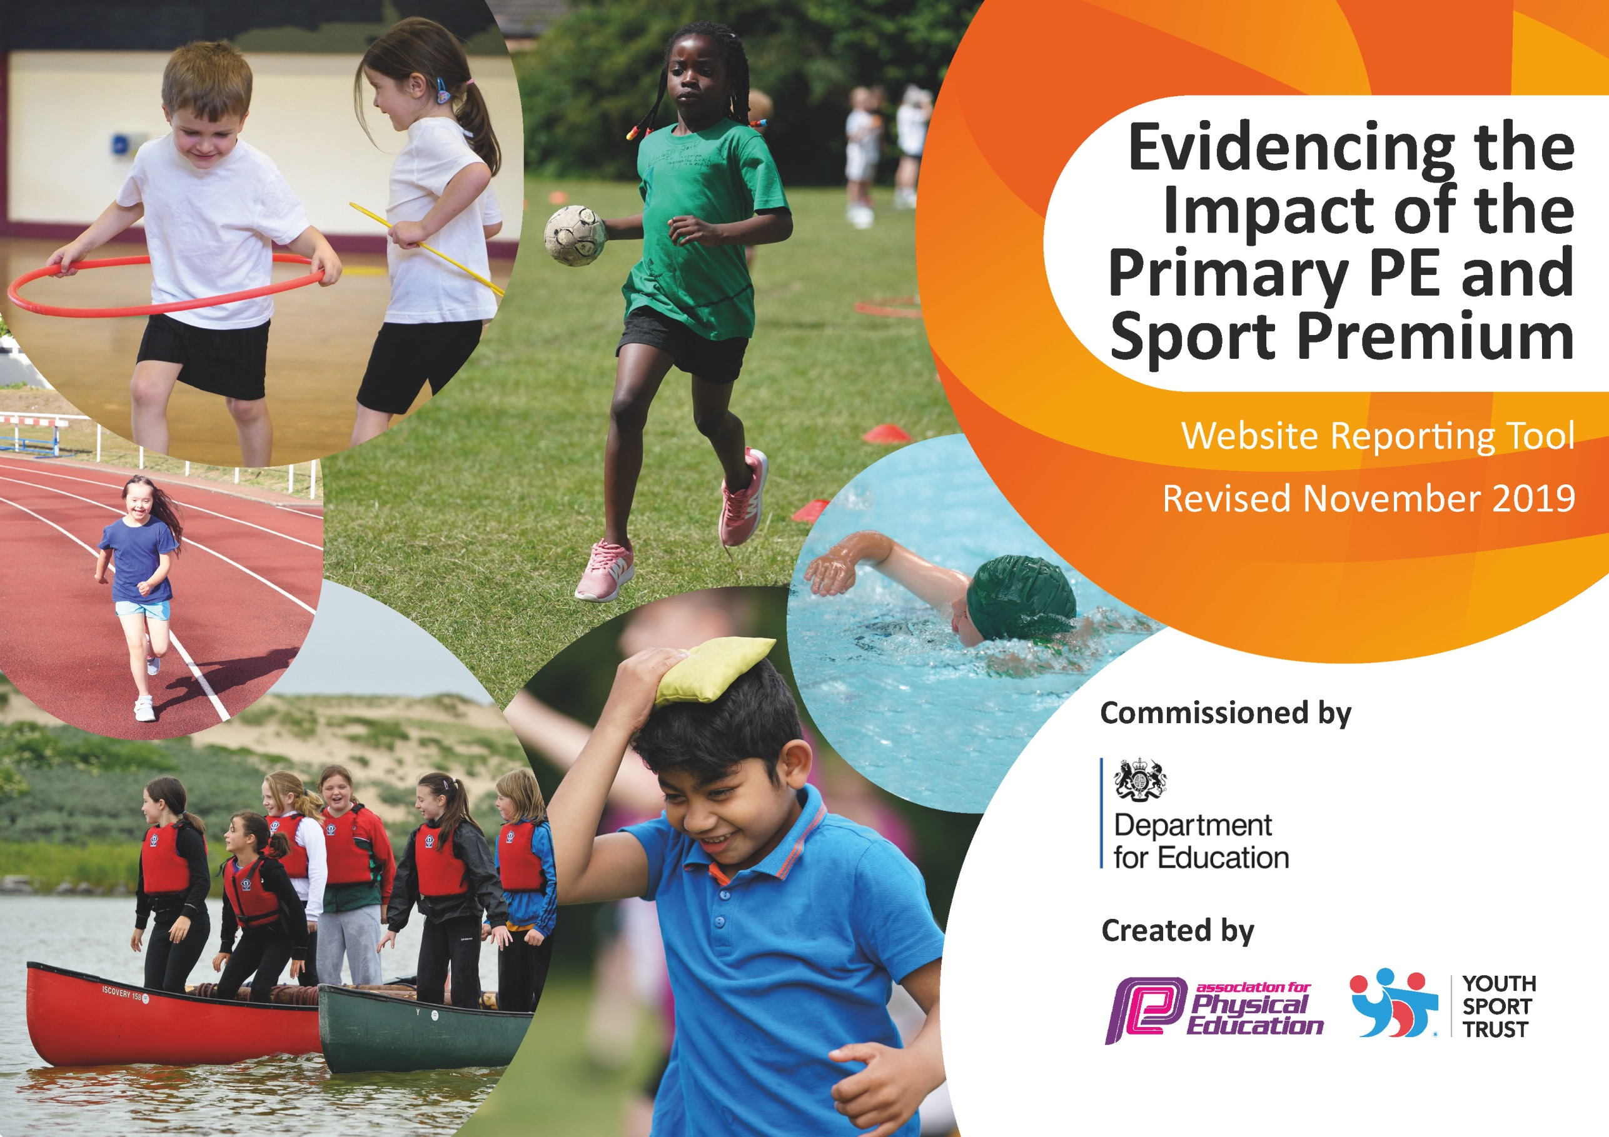
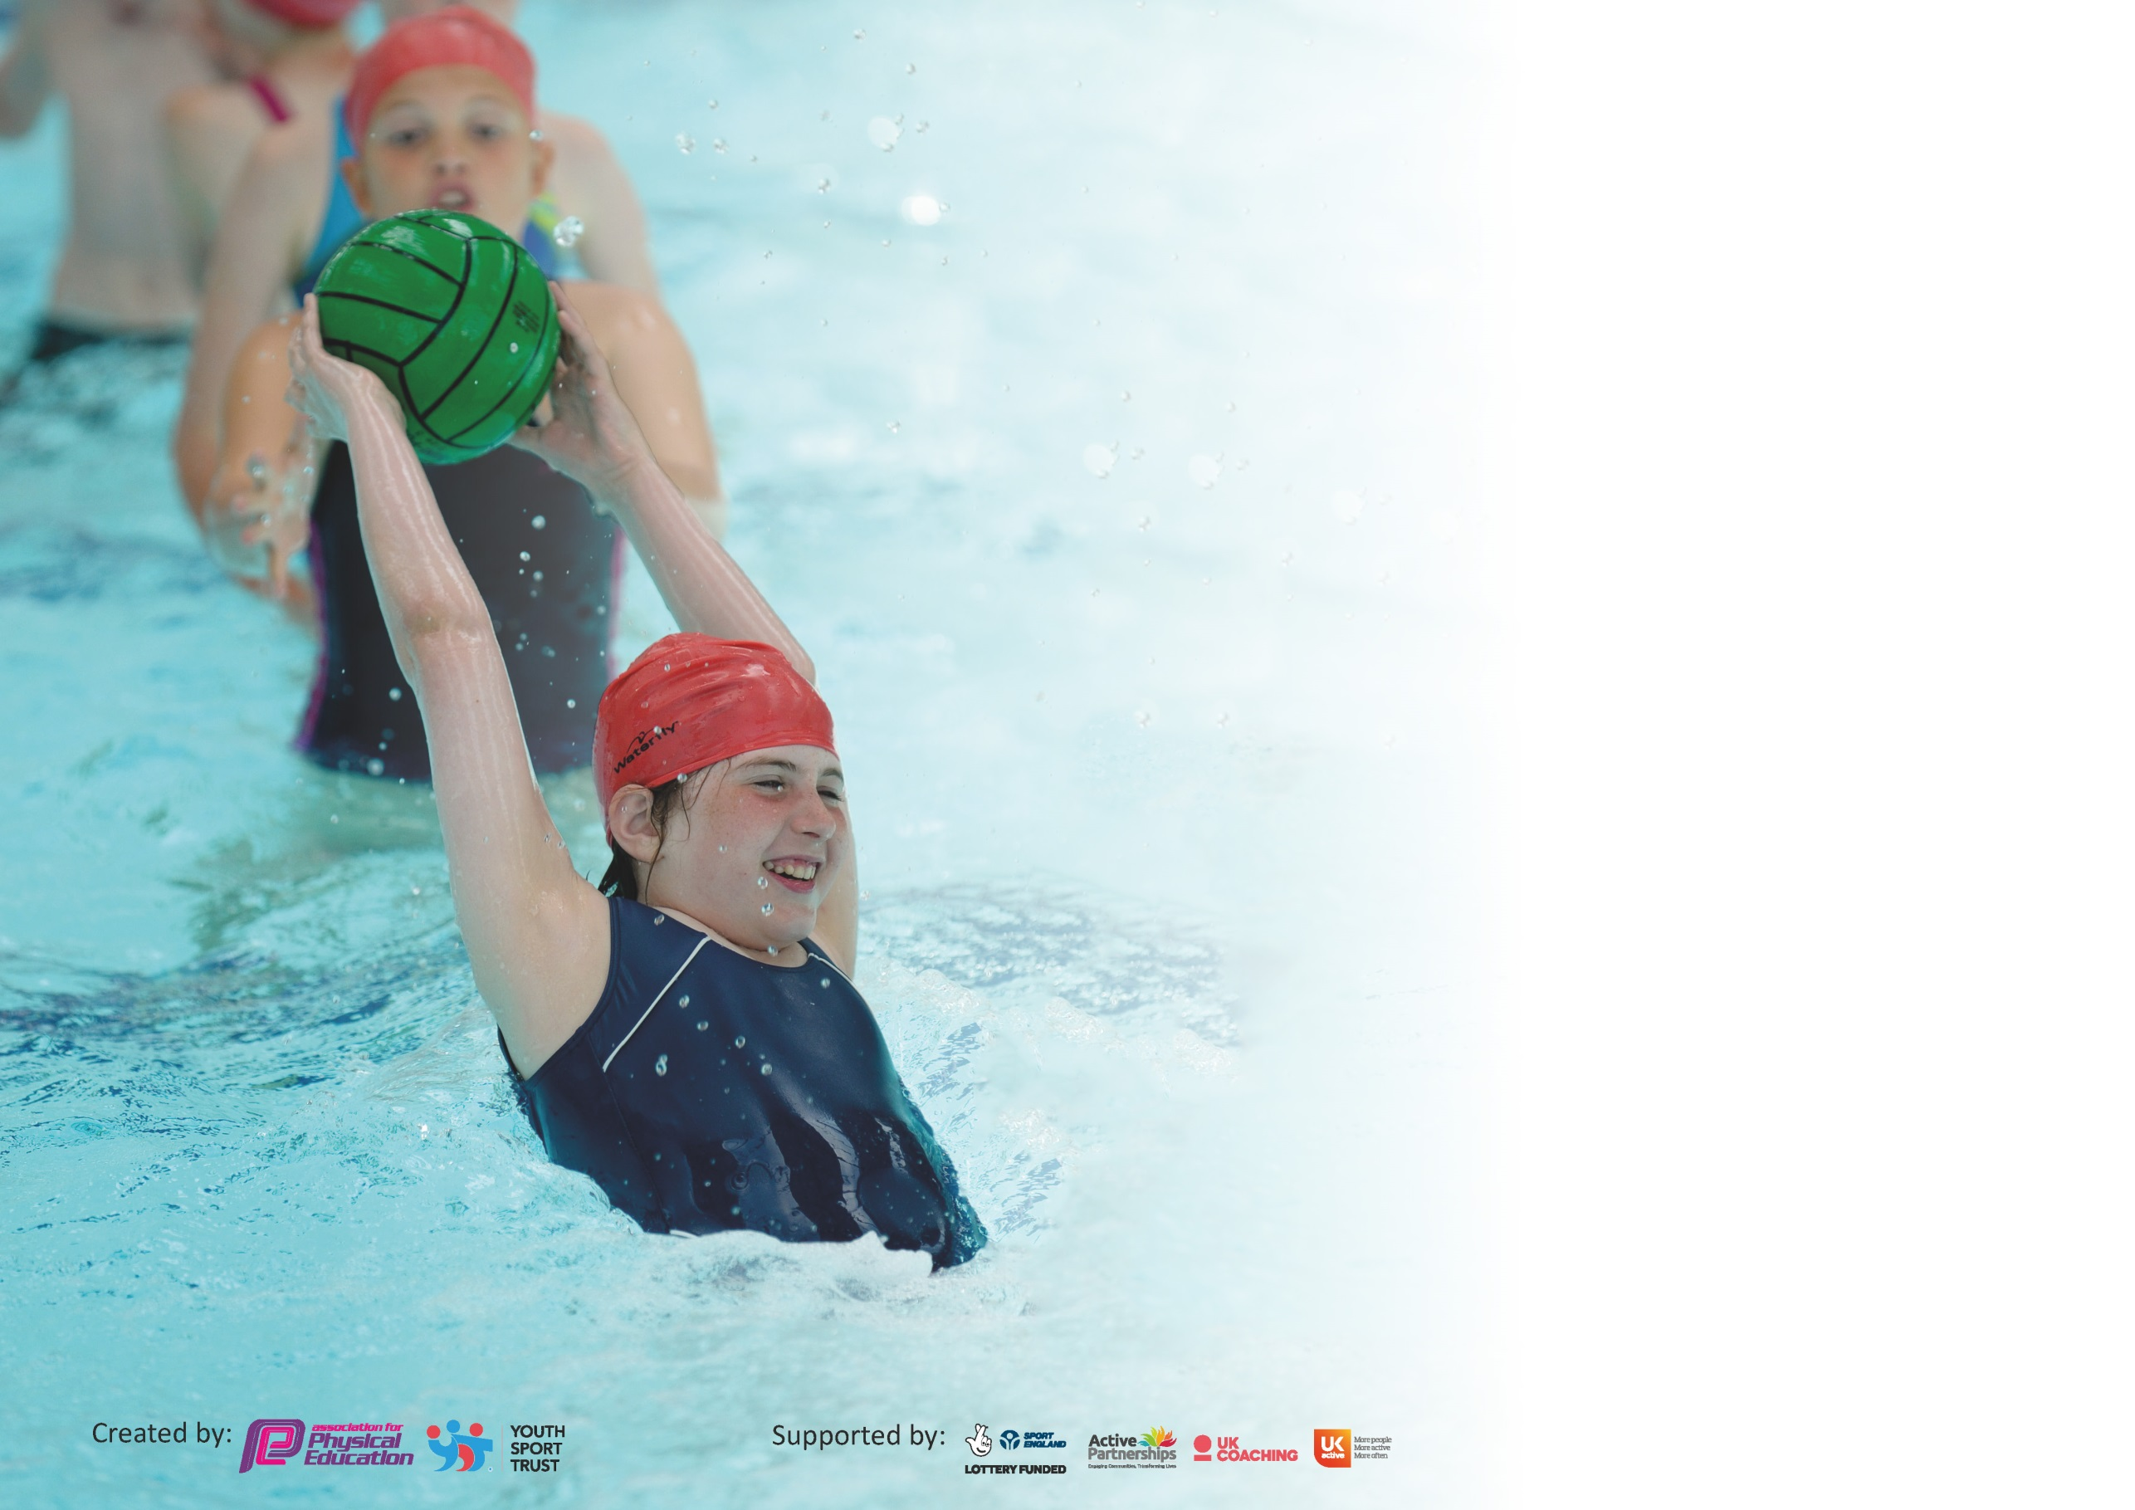

It is important that your grant is used effectively and based on school need. The Education Inspection Framework (Ofsted 2019 p64) makes clear there will be a focus on ‘whether leaders and those responsible for governors all understand their respective roles and perform these in a way that enhances the effectiveness of the school’.

Under the Quality of Education criteria (p41) inspectors consider the extent to which schools can articulate their curriculum (INTENT), construct their curriculum (IMPLEMENTATION) and demonstrate the outcomes which result (IMPACT).

To assist schools with common transferable language this template has been developed to utilise the same three headings which should make your plans easily transferable between working documents.

Schools must use the funding to make additional and sustainable improvements to the quality of Physical Education, School Sport and Physical Activity (PESSPA) they offer. This means that you should
use the Primary PE and Sport Premium to:

- Develop or add to the PESSPA activities that your school already offer
- Build capacity and capability within the school to ensure that improvements made now will benefit pupils joining the school in future years

Please visit gov.uk for the revised DfE guidance including the 5 key indicators across which schools should demonstrate an improvement. This document will help you to review your provision and to report your spend. DfE encourages schools to use this template as an effective way of meeting the reporting requirements of the Primary PE and Sport Premium.

We recommend you start by reflecting on the impact of current provision and reviewing the previous spend.

Schools are required to publish details of how they spend this funding as well as on the impact it has on pupils’ PE and sport participation and attainment by the end of the summer term or by 31st July 2020 at the latest.

We recommend regularly updating the table and publishing it on your website throughout the year. This evidences your ongoing self-evaluation of how you are using the funding to secure maximum, sustainable impact. Final copy must be posted on your website by the end of the academic year and no later than the 31st July 2020. To see an example of how to complete the table please click HERE.

Support for review and reflection - considering the 5 key indicators from DfE, what development needs are a priority for your setting and your pupils now and why? Use the space below to reflect on previous spend and key achievements and areas for development.

Key achievements to date until July 2021: | Areas for further improvement and baseline evidence of need:
All children met the national curriculum requirements for swimming and water safety.  Due to covid restrictions, no sporting competitions have been held either internally or externally. | Due to the national lockdowns, a significant number of children’s physical health and fitness has declined.  We need to rebuild children’s fitness and ability to sustain moderate exercise.

Meeting national curriculum requirements for swimming and water safety.
What percentage of your current Year 6 cohort swim competently, confidently and proficiently over a distance of at least 25 metres?  N.B. Even though your pupils may swim in another year please report on their attainment on leaving  primary school at the end of the summer term 2020. | 100%
What percentage of your current Year 6 cohort use a range of strokes effectively [for example, front crawl, backstroke and breaststroke]? | 100%
What percentage of your current Year 6 cohort perform safe self-rescue in different water-based situations? | 100%
Schools can choose to use the Primary PE and Sport Premium to provide additional provision for swimming but this must be for activity over and above the national curriculum requirements. Have you used it in this way? | Yes/No

Action Plan and Budget Tracking
Capture your intended annual spend against the 5 key indicators. Clarify the success criteria and evidence of impact that you intend to measure to evaluate for pupils today and for the future.

Academic Year: 2020/2021 | Total fund allocated: £16870 | Date Updated:
Key indicator 1: The engagement of all pupils in regular physical activity – Chief Medical Officer guidelines recommend that primary school pupils undertake at least 30 minutes of physical activity a day in school |  |  |  | Percentage of total allocation:
 |  |  |  | 77%
Intent | Implementation |  | Impact
Your school focus should be clear what you want the pupils to know and be able to do and about  what they need to learn and to  consolidate through practice: | Make sure your actions to achieve are linked to your intentions: | Funding allocated: | Evidence of impact: what do pupils now know and what can they now do? What has changed?: | Sustainability and suggested next steps:
To provide resources to support physical exercise and teamwork  To engage all children in regular physical exercise  To provide resources to support mental wellbeing. | To enable children to develop a positive attitude towards physical exercise and understand the importance of working together.  Training delivered to all staff.  Timetabled sessions  Introduce regular walks in the local area.  Whole school resources purchased and training delivered.  Timetabled sessions allow children to access this support throughout the year. | £9000  200  £4000 | Children engaged within the sessions and physically active.  Children working together and resolving conflict in a more positive manner.  Children partake in the regular walks. A greater understanding of the need for regular exercise and how this helps them to settle and get ready for learning.  Children have a greater understanding of a range of strategies to promote positive metal health. | New scheme of work purchased. Resources purchased to deliver the scheme of work  Sessions timetabled daily.
Key indicator 2: The profile of PESSPA (Physical Education, School Sport and Physical Activity) being raised across the school as a tool for whole school improvement |  |  |  | Percentage of total allocation:
 |  |  |  | 0%
Intent | Implementation |  | Impact
Your school focus should be clear what you want the pupils to know and be able to do and about  what they need to learn and to  consolidate through practice: | Make sure your actions to achieve are linked to your intentions: | Funding allocated: | Evidence of impact: what do pupils now know and what can they now do? What has changed?: | Sustainability and suggested next steps:
Increase the number of extra-curricular clubs run in school. | Ensure a range of clubs are offered throughout school taking into account that some children cannot attend after school clubs | 200 | A range of external sporting fixtures attended. | Extra curricular clubs planned for a range of year groups and spread across the year once Covid restrictions have been lifted.

Key indicator 3: Increased confidence, knowledge and skills of all staff in teaching PE and sport |  |  |  | Percentage of total allocation:
 |  |  |  | 6%
Intent | Implementation |  | Impact
Your school focus should be clear | Make sure your actions to | Funding | Evidence of impact: what do | Sustainability and suggested
what you want the pupils to know | achieve are linked to your | allocated: | pupils now know and what | next steps:
and be able to do and about | intentions: |  | can they now do? What has
what they need to learn and to |  |  | changed?:
consolidate through practice:
Improved role modelling of healthy active lifestyle behaviours by all school staff to reach all children | PE subject lead to provide updates throughout the year in staff meetings.  PE subject lead to meet with a wide range of children to discuss their PE lessons and ascertain their knowledge and understating on the subject.  Professional development in subject leadership for PE lead. | £1000 | Most children stated that they enjoyed PE and the extra curricular activities. | Continue to discuss with staff areas for development.
Key indicator 4: Broader experience of a range of sports and activities offered to all pupils |  |  |  | Percentage of total allocation:
 |  |  |  | 16%
Intent | Implementation |  | Impact
Your school focus should be clear | Make sure your actions to | Funding | Evidence of impact: what do | Sustainability and suggested
what you want the pupils to know | achieve are linked to your | allocated: | pupils now know and what | next steps:
and be able to do and about | intentions: |  | can they now do? What has
what they need to learn and to |  |  | changed?:
consolidate through practice:
Additional achievements:  Continue to offer a wide range of extra-curricular activities to all  children in school  Lunchtime supervisors offer a range of organised activities | Extra-curricular clubs offered to all year groups.  A rota of activities is delivered daily for children to access | £ 2200  £1000 | Children stated that they enjoy lunchtimes more as there is more to do. This has led to improved learning in afternoon lessons. | Continue to promote and offer clubs to a range of ages.  Lunchtime staff continue to deliver activities

Key indicator 5: Increased participation in competitive sport |  |  |  | Percentage of total allocation:
 |  |  |  | 0%
Intent | Implementation |  | Impact
Your school focus should be clear | Make sure your actions to | Funding | Evidence of impact: what do | Sustainability and suggested
what you want the pupils to know | achieve are linked to your | allocated: | pupils now know and what | next steps:
and be able to do and about | intentions: |  | can they now do? What has
what they need to learn and to |  |  | changed?:
consolidate through practice:
Enter a wider range of sports including more children | Create an overview of events for the year to allow clubs to be run cumulating in an event.  Create interschool events to support children who are not as competitive.  Use a spreadsheet to keep a record of which children have represented school.  Office to reply to emails to ensure that a place is booked | 0 | An increase in the number of competitive events entered from previous years when covid restrictions are lifted | Continue to plan for and enter events quickly

