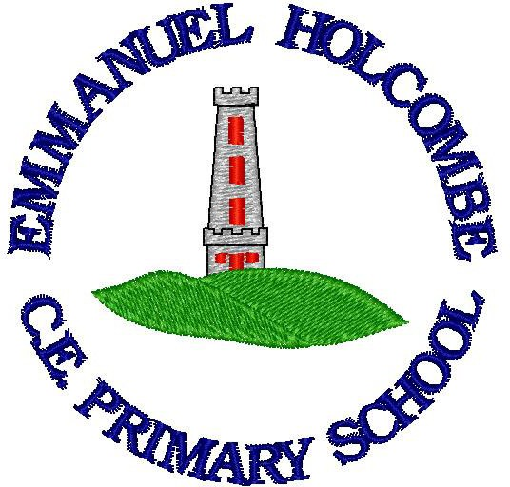

Emmanuel Holcombe C of E Primary Charging and remissions policy
Vision Statement

Jesus came to give us life in all its fullness. Our vision is that through faith, family and friendship, each of us can grow in love and learning, being tolerant, having resilience and developing enquiring minds, so that we can all experience the abundance Jesus came to give us.

Mission statement

In our small, friendly school, everyone respects and cares for one another
In our community, church, home and school we work together to grown in faith and friendship
In our learning we encourage each individual to reach their potential to grow through skills, knowledge and understanding

Policy written: May 2018 Reviewed: March 2022 Review date: March 2024

SCHOOL CHARGING AND REMISSIONS POLICY

INTRODUCTION

This charging and remissions policy complies with statutory requirements, has regard to the Authority's policy statements on charging and is reviewed on an annual basis.

CHARGING POLICY

Activities without charge

There will be no charge for the following activities:

- education provided wholly or mostly during school hours. This includes the supply of any materials, books, instruments, other equipment and also transport provided in school hours to carry pupils between the school and an activity;

- education provided outside school hours if it is part of the National Curriculum, or part of a syllabus for a prescribed public examination which the pupil is being prepared for at the school, or part of religious education;

- instrumental and vocal music tuition which is part of the National Curriculum or a public examination syllabus being followed by the pupil or the first access to the Key Stage 2 Programme of Instrumental and Vocal Tuition (Wider Opportunities);

- instrumental and vocal tuition for children looked after;

- entry for a prescribed public examination including re-sits provided that a pupil has been prepared for it at the school.

Voluntary Contributions

The school may ask for voluntary contributions towards the cost of school-time activities to assist with funding subject to the following conditions:

- parents will be informed at the outset that there is no obligation to pay for a particular activity.
- any children of parents who do not wish to contribute will not be treated any differently;
- where there are insufficient contributions to make the activity viable then the activity will be cancelled.

Chargeable Activities / Optional Extras

The school may recover the full costs of the following activities which may be provided directly or through commissioned services but charges will not exceed actual cost:

- educational or other activities provided wholly or mainly outside school hours which are not:

  - part of the National Curriculum;

  - part of a syllabus for a prescribed public examination which the pupil is being prepared for at school;

  - part of religious education.

At Emmanuel Holcombe CE Primary School these include:

- board and lodgings on residential visits (subject to remission arrangements).

- cost of entering a pupil for a public examination not prescribed in regulations, and for the cost of preparing a pupil for that examination outside school hours.

- cost of entering a pupil for a prescribed public examination including re-sits where no preparation has been provided by the school.

- provision of instrumental and vocal tuition, which takes place during the school day and which has been requested by parents/carers.

- child care facilities

Remissions Policy

Parents who are in receipt of Free School Meals or qualify for Pupil Premium may be entitled to support for some of the charges. You would qualify for Free School Meals if you meet the following criteria:

- Income Support
- Income-based Jobseeker’s Allowance
- Income-related Employment and Support Allowance
- Support under Part VI of the Immigration and Asylum Act 1999
- The guaranteed element of Pension Credit

- Child Tax Credit (provided you’re not also entitled to Working Tax Credit and have an annual gross income of no more than £16,190)
- Working Tax Credit run-on - paid for 4 weeks after you stop qualifying for Working Tax Credit
- Universal Credit - if you apply on or after 1 April 2018 your household income must be less than £7,400 a year (after tax and not including any benefits you get)
Children who get paid these benefits directly, instead of through a parent or guardian, can also get free school meals.
Your child might also get free school meals if you get any of these benefits and your child is both:

- younger than the compulsory age for starting school

- in full-time education

If your child is eligible for free school meals, they’ll remain eligible until they finish the phase of schooling (primary or secondary) they’re in on 31 March 2022.
Charges for other 'chargeable activities' may also be fully or partly remitted. Details of any remission arrangements will be made clear when parents are informed of charges for individual activities.

