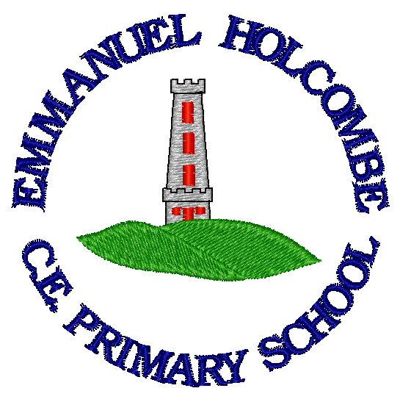

Emmanuel Holcombe C of E Primary
English curriculum

2022

National Curriculum Intent for English
The National Curriculum for English aims to ensure that all pupils:
• read easily, fluently and with good understanding
- develop the habit of reading widely and often, for both pleasure and information
- acquire a wide vocabulary, an understanding of grammar and knowledge of linguistic conventions for reading, writing and spoken language
- appreciate our rich and varied literary heritage
- write clearly, accurately and coherently, adapting their language and style in and for a range of contexts, purposes and audiences
- use discussion in order to learn; they should be able to elaborate and explain clearly their understanding and ideas
- are competent in the arts of speaking and listening, making formal presentations, demonstrating to others and participating in debate

Speaking and Listening at Emmanuel Holcombe C.E. Primary School
Intent
At Emmanuel Holcombe C.E. Primary School, we believe that good speaking and listening capabilities are crucial life skills which lead to better connections with others. The aims of teaching speaking and listening in our school are to develop children who:
- Listen attentively to a range of speakers
- Become increasingly active listeners who listen to understand rather than just reply
- Ask questions to further develop their understanding of what someone has said
- Participate in discussions and debate by listening to what has already been said and making relevant responses
- Know when to speak and when to listen
- Can express their ideas and opinions, articulate feelings and respond respectfully to the ideas, opinions and feelings of others
- Use an appropriate style and tone depending on the formality of the situation showing the correct use of Standard English when required
- Make formal presentations

Implementation
- Teachers give pupils sufficient practice of speaking and listening through whole class, paired and/or group discussions in every lesson
- A ‘no hands up’ is being implemented throughout school
- Speaking and listening is explicitly planned into English lessons, guided reading and Commando Jo sessions
- Commando Jo sessions and the outdoor learning curriculum highlight the importance of effective communication and allow children to experience speaking and listening in a range of environments and situations
- ‘Show and Tell’ occurs regularly within classes to enable children to practise their speaking and listening skills
- Class assemblies and performances allow children to perform to larger and more diverse audiences
- Open days involve our older children greeting guests and giving tours of the school
- Teachers speak and listen to children around school and have high expectations of children’s responses
- Teachers understand the importance of good speaking and listening skills
- Appropriate styles and tones including the use of Standard English are modelled by teachers
- Active listening is modelled by teachers

Impact
Pupils will:
  - make good progress from their own personal starting points
  - have the knowledge and skills to speak and listen in a range of situations and to a range of audiences
  - be increasingly active listeners

Reading at Emmanuel Holcombe C.E. Primary School
Intent
At Emmanuel Holcombe C.E. Primary School, our aim is for every child to become a fluent reader. We want children to become fluent readers in order for them to reach age related expectations or make accelerated progress from their starting point. As well as this, we want children to develop a love for reading and read for pleasure on a regular basis.
Our curriculum is designed around the needs of the pupils in our school and there are a variety of approaches to enable the pupils to make good progress.
The aims of teaching reading in our school are to develop pupils who:
- show high levels of achievement and exhibit very positive attitudes towards reading
- rapidly acquire a secure knowledge of letters and sounds and make sustained progress in learning to read fluently
- read easily and fluently with good understanding across both fiction and non-fiction
- acquire a wider vocabulary
- participate in the teaching of phonics knowledge, skills and understanding in a systematic and enjoyable way
- develop their reading in all subjects to support their acquisition of knowledge.
- develop a love of reading
- read for pleasure both at home and school on a regular basis
- through their reading develop culturally, emotionally, intellectually, socially and spiritually
- and develop good comprehension drawing from their linguistic knowledge.

Implementation

- the school uses a systematic, synthetic phonics programme throughout phase 1 to 6 to ensure consistency from one year to the next
- teachers give pupils sufficient practice in reading and re-reading books that match the grapheme-phoneme correspondences they know, both at school and at home
- the half-termly assessment of pupils’ phonics progress is detailed to identify any pupil who is falling behind the programme’s pace and targeted support is put into place immediately
- banded books ensure that children read at the appropriate level following completion of phase 5 phonics
- teachers have a clear understanding of how pupils learn to read
- long term planning with dedicated reading phases ensures consistency and progression
- guided reading sessions start in reception, are taught regularly
- cross curricular reading is integrated into the curriculum
- reading for pleasure is actively encouraged and celebrated
- books available in school support diversity and inclusion
- staff read aloud stories, poems, rhymes and non-fiction that develop pupils' vocabulary, language comprehension and love of reading.

Impact
Pupils will:
  - make good progress from their own personal starting points
  - have the knowledge and skills to read and understand a range of genres
  - be active readers
  - make personal reading choices.

Writing at Emmanuel Holcombe Primary School
Intent
Emmanuel Holcombe C.E. Primary School believes that English skills are vital to the development of children, so they are prepared for their future life. A broad and balanced English programme using objectives from the National Curriculum 2014, determines the skills that each year group and Key Stage must cover. A range of genres is studied and promoted. A variety of resources are used to promote a reading and writing culture. Children are given a range of writing opportunities including the use of paired, group and independent writing tasks. A culture of learning from each other is promoted through use of co-operative learning structures. This is developed across both key stages, so that the children learn to respond appropriately and supportively to each other regardless of gender, age, cultural or ethnic background.
The aims of teaching writing in our school are to develop pupils who:
- show high levels of achievement and exhibit very positive attitudes towards writing
- use and understand language as speakers, readers and writers
- are competent, confident and independent in the use of language in their writing
- have an awareness of different audiences and purposes for writing
- apply their grammatical knowledge in their writing
- apply their phonetical and spelling knowledge in their writing
- apply the English language in all areas of the curriculum.

Implementation
- long term planning ensures consistency and progression
- high quality texts are used to model and inspire high quality writing
- writing is constructed through a three-phase approach of reading, reading and analysing, and writing
- grammar is taught frequently and in context
- teachers have a clear understanding of how children learn to write
- children receive feedback on spelling, grammar, punctuation and handwriting across all aspects of the curriculum
- the process of editing writing is integrated into the whole curriculum.
Impact
- make good progress from their own personal starting points
- have the knowledge and skills to write clearly, accurately and coherently for a range of contexts
- show an awareness of the audience and purpose of their writing
- view editing as an integral part of the writing process.

Programmes of Study

EYFS
Communication and Language
The development of children’s spoken language underpins all seven areas of learning and development. Children’s back-and-forth interactions from an early age form the foundations for language and cognitive development. The number and quality of the conversations they have with adults and peers throughout the day in a language-rich environment is crucial. By commenting on what children are interested in or doing, and echoing back what they say with new vocabulary added, practitioners will build children's language effectively. Reading frequently to children, and engaging them actively in stories, non-fiction, rhymes and poems, and then providing them with extensive opportunities to use and embed new words in a range of contexts, will give children the opportunity to thrive. Through conversation, story-telling and role play, where children share their ideas with support and modelling from their teacher, and sensitive questioning that invites them to elaborate, children become comfortable using a rich range of vocabulary and language structures.

Literacy
It is crucial for children to develop a life-long love of reading. Reading consists of two dimensions: language comprehension and word reading. Language comprehension (necessary for both reading and writing) starts from birth. It only develops when adults talk with children about the world around them and the books (stories and non-fiction) they read with them, and enjoy rhymes, poems and songs together. Skilled word reading, taught later, involves both the speedy working out of the pronunciation of unfamiliar printed words (decoding) and the speedy recognition of familiar printed words. Writing involves transcription (spelling and handwriting) and composition (articulating ideas and structuring them in speech, before writing).
Early Learning Goals
Communication and Language
ELG: Listening, Attention and Understanding
Children at the expected level of development will:
- Listen attentively and respond to what they hear with relevant questions, comments and actions when being read to and during whole class discussions and small group interactions;
- Make comments about what they have heard and ask questions to clarify their understanding;
- Hold conversation when engaged in back-and-forth exchanges with their teacher and peers.
ELG: Speaking
Children at the expected level of development will:
- Participate in small group, class and one-to-one discussions, offering their own ideas, using recently introduced vocabulary;
- Offer explanations for why things might happen, making use of recently introduced vocabulary from stories, non-fiction, rhymes and poems when appropriate;
- Express their ideas and feelings about their experiences using full sentences, including use of past, present and future tenses and making use of conjunctions, with modelling and support from their teacher.

Literacy
ELG: Comprehension
Children at the expected level of development will:
- Demonstrate understanding of what has been read to them by retelling stories and narratives using their own words and recently introduced vocabulary;
- Anticipate – where appropriate – key events in stories;
- Use and understand recently introduced vocabulary during discussions about stories, non-fiction, rhymes and poems and during role-play.
ELG: Word Reading
Children at the expected level of development will:
- Say a sound for each letter in the alphabet and at least 10 digraphs;
- Read words consistent with their phonic knowledge by sound-blending;
- Read aloud simple sentences and books that are consistent with their phonic knowledge, including some common exception words.
ELG: Writing
Children at the expected level of development will:
- Write recognisable letters, most of which are correctly formed;
- Spell words by identifying sounds in them and representing the sounds with a letter or letters;
- Write simple phrases and sentences that can be read by others.

National Curriculum

The programmes of study for English are set out year-by-year for key stage 1 and two-yearly for key stage 2. The single year blocks at key stage 1 reflect the rapid pace of development in word reading during these 2 years. Schools are, however, only required to teach the relevant programme of study by the end of the key stage. Within each key stage, schools therefore have the flexibility to introduce content earlier or later than set out in the programme of study. In addition, schools can introduce key stage content during an earlier key stage if appropriate. All schools are also required to set out their school curriculum for English on a year-by-year basis and make this information available online.

Spoken language – years 1 to 6
Pupils should be taught to:
- listen and respond appropriately to adults and their peers
- ask relevant questions to extend their understanding and knowledge
- use relevant strategies to build their vocabulary
- articulate and justify answers, arguments and opinions
- give well-structured descriptions, explanations and narratives for different purposes, including for expressing feelings
- maintain attention and participate actively in collaborative conversations, staying on topic and initiating and responding to comments
- use spoken language to develop understanding through speculating, hypothesising, imagining and exploring ideas
- speak audibly and fluently with an increasing command of Standard English
- participate in discussions, presentations, performances, role play/improvisations and debates
- gain, maintain and monitor the interest of the listener(s)
- consider and evaluate different viewpoints, attending to and building on the contributions of others
- select and use appropriate registers for effective communication.

Year 1
Reading - word reading
Pupils should be taught to:
- apply phonic knowledge and skills as the route to decode words
- respond speedily with the correct sound to graphemes (letters or groups of letters) for all 40+ phonemes, including, where applicable, alternative sounds for graphemes
- read accurately by blending sounds in unfamiliar words containing GPCs that have been taught
- read common exception words, noting unusual correspondences between spelling and sound and where these occur in the word
- read words containing taught GPCs and –s, –es, –ing, –ed, –er and –est endings
- read other words of more than one syllable that contain taught GPCs
- read words with contractions [for example, I’m, I’ll, we’ll], and understand that the apostrophe represents the omitted letter(s)
- read books aloud, accurately, that are consistent with their developing phonic knowledge and that do not require them to use other strategies to work out words
- reread these books to build up their fluency and confidence in word reading

Reading - comprehension
Pupils should be taught to:
- develop pleasure in reading, motivation to read, vocabulary and understanding by:
  - listening to and discussing a wide range of poems, stories and non-fiction at a level beyond that at which they can read independently
  - being encouraged to link what they read or hear to their own experiences
  - becoming very familiar with key stories, fairy stories and traditional tales, retelling them and considering their particular characteristics
  - recognising and joining in with predictable phrases
  - learning to appreciate rhymes and poems, and to recite some by heart
  - discussing word meanings, linking new meanings to those already known
- understand both the books they can already read accurately and fluently and those they listen to by:
  - drawing on what they already know or on background information and vocabulary provided by the teacher
  - checking that the text makes sense to them as they read, and correcting inaccurate reading
  - discussing the significance of the title and events
  - making inferences on the basis of what is being said and done
  - predicting what might happen on the basis of what has been read so far
- participate in discussion about what is read to them, taking turns and listening to what others say
- explain clearly their understanding of what is read to them

Writing - transcription
Pupils should be taught to:
- spell:
  - words containing each of the 40+ phonemes already taught
  - common exception words
  - the days of the week
- name the letters of the alphabet:
  - naming the letters of the alphabet in order
  - using letter names to distinguish between alternative spellings of the same sound
- add prefixes and suffixes:
  - using the spelling rule for adding –s or –es as the plural marker for nouns and the third person singular marker for verbs
  - using the prefix un–
  - using –ing, –ed, –er and –est where no change is needed in the spelling of root words [for example, helping, helped, helper, eating, quicker, quickest]
- apply simple spelling rules and guidance, as listed in English appendix 1
- write from memory simple sentences dictated by the teacher that include words using the GPCs and common exception words taught so far

Handwriting
Pupils should be taught to:
- sit correctly at a table, holding a pencil comfortably and correctly
- begin to form lower-case letters in the correct direction, starting and finishing in the right place
- form capital letters
- form digits 0-9
- understand which letters belong to which handwriting ‘families’ (ie letters that are formed in similar ways) and to practise these

Year 2 Reading - word reading
Pupils should be taught to:
- continue to apply phonic knowledge and skills as the route to decode words until automatic decoding has become embedded and reading is fluent
- read accurately by blending the sounds in words that contain the graphemes taught so far, especially recognising alternative sounds for graphemes
- read accurately words of two or more syllables that contain the same graphemes as above
- read words containing common suffixes
- read further common exception words, noting unusual correspondences between spelling and sound and where these occur in the word
- read most words quickly and accurately, without overt sounding and blending, when they have been frequently encountered
- read aloud books closely matched to their improving phonic knowledge, sounding out unfamiliar words accurately, automatically and without undue hesitation
- reread these books to build up their fluency and confidence in word reading

Reading - comprehension
Pupils should be taught to:
- develop pleasure in reading, motivation to read, vocabulary and understanding by:
  - listening to, discussing and expressing views about a wide range of contemporary and classic poetry, stories and non-fiction at a level beyond that at which they can read independently
  - discussing the sequence of events in books and how items of information are related
  - becoming increasingly familiar with and retelling a wider range of stories, fairy stories and traditional tales
  - being introduced to non-fiction books that are structured in different ways
  - recognising simple recurring literary language in stories and poetry
  - discussing and clarifying the meanings of words, linking new meanings to known vocabulary
  - discussing their favourite words and phrases
  - continuing to build up a repertoire of poems learnt by heart, appreciating these and reciting some, with appropriate intonation to make the meaning clear
- understand both the books that they can already read accurately and fluently and those that they listen to by:
  - drawing on what they already know or on background information and vocabulary provided by the teacher
  - checking that the text makes sense to them as they read, and correcting inaccurate reading
  - making inferences on the basis of what is being said and done
  - answering and asking questions
  - predicting what might happen on the basis of what has been read so far
- participate in discussion about books, poems and other works that are read to them and those that they can read for themselves, taking turns and listening to what others say
- explain and discuss their understanding of books, poems and other material, both those that they listen to and those that they read for themselves

Writing - transcription
Pupils should be taught to:
- spell by:
  - segmenting spoken words into phonemes and representing these by graphemes, spelling many correctly
  - learning new ways of spelling phonemes for which 1 or more spellings are already known, and learn some words with each spelling, including a few common homophones
  - learning to spell common exception words
  - learning to spell more words with contracted forms
  - learning the possessive apostrophe (singular) [for example, the girl’s book]
  - distinguishing between homophones and near-homophones
- add suffixes to spell longer words including –ment, –ness, –ful, –less, –ly
- apply spelling rules and guidance, as listed in English appendix 1
- write from memory simple sentences dictated by the teacher that include words using the GPCs, common exception words and punctuation taught so far

Handwriting
Pupils should be taught to:
- form lower-case letters of the correct size relative to one another
- start using some of the diagonal and horizontal strokes needed to join letters and understand which letters, when adjacent to one another, are best left unjoined
- write capital letters and digits of the correct size, orientation and relationship to one another and to lower-case letters
- use spacing between words that reflects the size of the letters
- read aloud what they have written with appropriate intonation to make the meaning clear

Writing - composition

Pupils should be taught to:
- develop positive attitudes towards and stamina for writing by:
  - writing narratives about personal experiences and those of others (real and fictional)
  - writing about real events
  - writing poetry
  - writing for different purposes
- consider what they are going to write before beginning by:
  - planning or saying out loud what they are going to write about
  - writing down ideas and/or key words, including new vocabulary
  - encapsulating what they want to say, sentence by sentence
- make simple additions, revisions and corrections to their own writing by:
  - evaluating their writing with the teacher and other pupils
  - rereading to check that their writing makes sense and that verbs to indicate time are used correctly and consistently, including verbs in the continuous form
  - proofreading to check for errors in spelling, grammar and punctuation (for example, ends of sentences punctuated correctly)
- read aloud what they have written with appropriate intonation to make the meaning clear

Writing - vocabulary, grammar and punctuation
Pupils should be taught to:
- develop their understanding of the concepts set out in English appendix 2 by:
  - learning how to use both familiar and new punctuation correctly - see English appendix 2, including full stops, capital letters, exclamation marks, question marks, commas for lists and apostrophes for contracted forms and the possessive (singular)
  - learn how to use:
  - sentences with different forms: statement, question, exclamation, command
  - expanded noun phrases to describe and specify [for example, the blue butterfly]
  - the present and past tenses correctly and consistently, including the progressive form
  - subordination (using when, if, that, or because) and co-ordination (using or, and, or but)
  - the grammar for year 2 in English appendix 2
  - some features of written Standard English
- use and understand the grammatical terminology in English appendix 2 in discussing their writing

Years 3 and 4 programme of study

Reading - word reading
Pupils should be taught to:
- apply their growing knowledge of root words, prefixes and suffixes (etymology and morphology) as listed in - see English appendix 1 , both to read aloud and to understand the meaning of new words they meet
- read further exception words, noting the unusual correspondences between spelling and sound, and where these occur in the word

Reading - comprehension
Pupils should be taught to:
- develop positive attitudes to reading, and an understanding of what they read, by:
  - listening to and discussing a wide range of fiction, poetry, plays, non-fiction and reference books or textbooks
  - reading books that are structured in different ways and reading for a range of purposes
  - using dictionaries to check the meaning of words that they have read
  - increasing their familiarity with a wide range of books, including fairy stories, myths and legends, and retelling some of these orally
  - identifying themes and conventions in a wide range of books
  - preparing poems and play scripts to read aloud and to perform, showing understanding through intonation, tone, volume and action
  - discussing words and phrases that capture the reader’s interest and imagination
  - recognising some different forms of poetry [for example, free verse, narrative poetry]
- understand what they read, in books they can read independently, by:
  - checking that the text makes sense to them, discussing their understanding, and explaining the meaning of words in context
  - asking questions to improve their understanding of a text
  - drawing inferences such as inferring characters’ feelings, thoughts and motives from their actions, and justifying inferences with evidence
  - predicting what might happen from details stated and implied
  - identifying main ideas drawn from more than 1 paragraph and summarising these
  - identifying how language, structure, and presentation contribute to meaning
- retrieve and record information from non-fiction
- participate in discussion about both books that are read to them and those they can read for themselves, taking turns and listening to what others say

Writing - transcription
Pupils should be taught to:
- use further prefixes and suffixes and understand how to add them - see English appendix 1
- spell further homophones
- spell words that are often misspelt - see English appendix 1
- place the possessive apostrophe accurately in words with regular plurals [for example, girls’, boys’] and in words with irregular plurals [for example, children’s]
- use the first 2 or 3 letters of a word to check its spelling in a dictionary
- write from memory simple sentences, dictated by the teacher, that include words and punctuation taught so far

Handwriting
Pupils should be taught to:
- use the diagonal and horizontal strokes that are needed to join letters and understand which letters, when adjacent to one another, are best left unjoined
- increase the legibility, consistency and quality of their handwriting, [for example, by ensuring that the downstrokes of letters are parallel and equidistant, and that lines of writing are spaced sufficiently so that the ascenders and descenders of letters do not touch]

Writing - composition
Pupils should be taught to:
- plan their writing by:
  - discussing writing similar to that which they are planning to write in order to understand and learn from its structure, vocabulary and grammar
  - discussing and recording ideas
- draft and write by:
  - composing and rehearsing sentences orally (including dialogue), progressively building a varied and rich vocabulary and an increasing range of sentence structures English appendix 2
  - organising paragraphs around a theme
  - in narratives, creating settings, characters and plot
  - in non-narrative material, using simple organisational devices [for example, headings and sub-headings]
- evaluate and edit by:
  - assessing the effectiveness of their own and others’ writing and suggesting improvements
  - proposing changes to grammar and vocabulary to improve consistency, including the accurate use of pronouns in sentences
- proofread for spelling and punctuation errors
- read their own writing aloud to a group or the whole class, using appropriate intonation and controlling the tone and volume so that the meaning is clear

Writing - vocabulary, grammar and punctuation
Pupils should be taught to:
- develop their understanding of the concepts set out in English appendix 2 by:
  - extending the range of sentences with more than one clause by using a wider range of conjunctions, including: when, if, because, although
  - using the present perfect form of verbs in contrast to the past tense
  - choosing nouns or pronouns appropriately for clarity and cohesion and to avoid repetition
  - using conjunctions, adverbs and prepositions to express time and cause
  - using fronted adverbials
  - learning the grammar for years 3 and 4 in [English appendix 2]/government/uploads/system/uploads/attachment_data/file/335190/English_Appendix_2_-_Vocabulary_grammar_and_punctuation.pdf)
- indicate grammatical and other features by:
  - using commas after fronted adverbials
  - indicating possession by using the possessive apostrophe with plural nouns
  - using and punctuating direct speech
- use and understand the grammatical terminology in English appendix 2 accurately and appropriately when discussing their writing and reading

Years 5 and 6 programme of study

Reading - word reading
Pupils should be taught to:
- apply their growing knowledge of root words, prefixes and suffixes (morphology and etymology), as listed in English appendix 1, both to read aloud and to understand the meaning of new words that they meet

Reading - comprehension
Pupils should be taught to:
- maintain positive attitudes to reading and an understanding of what they read by:
  - continuing to read and discuss an increasingly wide range of fiction, poetry, plays, non-fiction and reference books or textbooks
  - reading books that are structured in different ways and reading for a range of purposes
  - increasing their familiarity with a wide range of books, including myths, legends and traditional stories, modern fiction, fiction from our literary heritage, and books from other cultures and traditions
  - recommending books that they have read to their peers, giving reasons for their choices
  - identifying and discussing themes and conventions in and across a wide range of writing
  - making comparisons within and across books
  - learning a wider range of poetry by heart
  - preparing poems and plays to read aloud and to perform, showing understanding through intonation, tone and volume so that the meaning is clear to an audience
- understand what they read by:
  - checking that the book makes sense to them, discussing their understanding and exploring the meaning of words in context
  - asking questions to improve their understanding
  - drawing inferences such as inferring characters’ feelings, thoughts and motives from their actions, and justifying inferences with evidence
  - predicting what might happen from details stated and implied
  - summarising the main ideas drawn from more than 1 paragraph, identifying key details that support the main ideas
  - identifying how language, structure and presentation contribute to meaning
- discuss and evaluate how authors use language, including figurative language, considering the impact on the reader
- distinguish between statements of fact and opinion
- retrieve, record and present information from non-fiction
- participate in discussions about books that are read to them and those they can read for themselves, building on their own and others’ ideas and challenging views courteously
- explain and discuss their understanding of what they have read, including through formal presentations and debates, maintaining a focus on the topic and using notes where necessary
- provide reasoned justifications for their views

Writing - transcription

Spelling - see English appendix 1
Pupils should be taught to:
- use further prefixes and suffixes and understand the guidance for adding them
- spell some words with ‘silent’ letters [for example, knight, psalm, solemn]
- continue to distinguish between homophones and other words which are often confused
- use knowledge of morphology and etymology in spelling and understand that the spelling of some words needs to be learnt specifically, as listed in English appendix 1
- use dictionaries to check the spelling and meaning of words
- use the first 3 or 4 letters of a word to check spelling, meaning or both of these in a dictionary
- use a thesaurus

Handwriting and presentation
Pupils should be taught to:
- write legibly, fluently and with increasing speed by:
  - choosing which shape of a letter to use when given choices and deciding whether or not to join specific letters
  - choosing the writing implement that is best suited for a task

Writing - composition
Pupils should be taught to:
- plan their writing by:
  - identifying the audience for and purpose of the writing, selecting the appropriate form and using other similar writing as models for their own
  - noting and developing initial ideas, drawing on reading and research where necessary
  - in writing narratives, considering how authors have developed characters and settings in what pupils have read, listened to or seen performed
- draft and write by:
  - selecting appropriate grammar and vocabulary, understanding how such choices can change and enhance meaning
  - in narratives, describing settings, characters and atmosphere and integrating dialogue to convey character and advance the action
  - précising longer passages
  - using a wide range of devices to build cohesion within and across paragraphs
  - using further organisational and presentational devices to structure text and to guide the reader [for example, headings, bullet points, underlining]
- evaluate and edit by:
  - assessing the effectiveness of their own and others’ writing
  - proposing changes to vocabulary, grammar and punctuation to enhance effects and clarify meaning
  - ensuring the consistent and correct use of tense throughout a piece of writing
  - ensuring correct subject and verb agreement when using singular and plural, distinguishing between the language of speech and writing and choosing the appropriate register
- proofread for spelling and punctuation errors
- perform their own compositions, using appropriate intonation, volume, and movement so that meaning is clear

Writing - vocabulary, grammar and punctuation
Pupils should be taught to:
- develop their understanding of the concepts set out in English appendix 2 by:
  - recognising vocabulary and structures that are appropriate for formal speech and writing, including subjunctive forms
  - using passive verbs to affect the presentation of information in a sentence
  - using the perfect form of verbs to mark relationships of time and cause
  - using expanded noun phrases to convey complicated information concisely
  - using modal verbs or adverbs to indicate degrees of possibility
  - using relative clauses beginning with who, which, where, when, whose, that or with an implied (ie omitted) relative pronoun
  - learning the grammar for years 5 and 6 in English appendix 2
- indicate grammatical and other features by:
  - using commas to clarify meaning or avoid ambiguity in writing
  - using hyphens to avoid ambiguity
  - using brackets, dashes or commas to indicate parenthesis
  - using semicolons, colons or dashes to mark boundaries between independent clauses
  - using a colon to introduce a list
  - punctuating bullet points consistently
- use and understand the grammatical terminology in English appendix 2 accurately and appropriately in discussing their writing and reading

Emmanuel Holcombe English curriculum
EYFS
Nursery | Reception | Early learning goal –
•  • | • | Communication and Language  ELG: Listening, Attention and Understanding  Children at the expected level of development will:  - Listen attentively and respond to what they hear with relevant questions, comments and actions when being read to and during whole class discussions and small group interactions;  - Make comments about what they have heard and ask questions to clarify their understanding;  - Hold conversation when engaged in back-and-forth exchanges with their teacher and peers.  ELG: Speaking  Children at the expected level of development will:  - Participate in small group, class and one-to-one discussions, offering their own ideas, using recently introduced vocabulary;  - Offer explanations for why things might happen, making use of recently introduced vocabulary from stories, non-fiction, rhymes and poems when appropriate;  - Express their ideas and feelings about their experiences using full sentences, including use of past, present and future tenses and making use of conjunctions, with modelling and support from their teacher.  Literacy  ELG: Comprehension  Children at the expected level of development will:  - Demonstrate understanding of what has been read to them by retelling stories and narratives using their own words and recently introduced vocabulary;  - Anticipate – where appropriate – key events in stories;  - Use and understand recently introduced vocabulary during discussions about stories, non-fiction, rhymes and poems and during role-play.  ELG: Word Reading  Children at the expected level of development will:  - Say a sound for each letter in the alphabet and at least 10 digraphs;  - Read words consistent with their phonic knowledge by sound-blending;  - Read aloud simple sentences and books that are consistent with their phonic knowledge, including some common exception words.  ELG: Writing  Children at the expected level of development will:  - Write recognisable letters, most of which are correctly formed;  - Spell words by identifying sounds in them and representing the sounds with a letter or letters;  - Write simple phrases and sentences that can be read by others.

Speaking and Listening

Reading – Word Reading and Comprehension
Word Reading –
GR – guided reading EL – English lessons CC – Cross- curricular reading SL – Spelling lessons
Year 1 and 2 | Year 3 and 4 | Year 5 and 6
See Phonics Curriculum Progression Document for progression of skills up to Level 6. | - Read books at an age appropriate interest level. (GR)  - Use knowledge of root words to understand meanings of words. (SL)  - Use prefixes to understand meanings including: un-, dis-, in-mis-, re-, im-, in-, il-, ir-, sub-, tele, inter-, super-, anti-, auto-. (SL)  - Use suffixes to understand meanings. -ly, -ous, -ation, -tion,  -ssion, -cian, -sion. (SL)  - Read and understand words from the Yr3/4 word list. (SL) | - Read books at an age appropriate interest level.  - Use knowledge of root words to understand meanings of words.  - Use suffixes to understand meanings. (list) -ant, -ance,  -ancy, -ent, -ence, -ency, -ible, -able, -ibly, -ably. (SL)  - Read and understand words from the Yr5/6 word list. (SL)

Comprehension Objectives
EL – English Lessons GR – Guided Reading TR – Teacher reading to the class outside the English Lesson CP – Class performances/plays
CC- cross-curricular reading
Year 1 and 2 | Year 3 and 4 | Year 5 and 6
Comprehension Objectives  - Listen to, discuss and express views about a range of texts at a level beyond that at which they can read independently, including stories, non-fiction, and contemporary and classic poetry. (EL + TR)  - Agree rules for effective discussion. (GR)  - Consider other points of view. (GR)  - Make personal reading choices and explain reasons for choices. (GR)  - Participate in discussions by taking turns and listening to what others say. (GR)  - Make contributions to whole class discussions. (EL +TR)  - Make contributions to group discussions. (GR)  - Listen and respond to contributions from others. (EL+TR+GR)  - Read a range of non-fiction texts which are organised in different ways, including information, explanations, instructions, recounts and reports. (EL, GR + TR)  - Frequently listen to stories, poems and non-fiction that they cannot yet read by themselves including whole books. (EL, TR + GR)  - Orally retell a wider range of stories, fairy tales and traditional tales. (EL + GR)  - Sequence and discuss the main events in stories and recounts. (EL)  - Discuss the title and how it relates to the events in the whole story. (GR)  - Learn and recite a range of poems using appropriate intonation. (EL, GR)  - Use tone and intonation when reading aloud. (GR)  - Introduce and discuss words within the context of a text, linking new meanings to known vocabulary. (EL + GR)  - Identify, discuss and collect favourite words and phrases. (EL)  - Recognise the use of repetitive language within a text or poem (e.g. run, run as fast as you can)and across texts(e.g. long, long ago in a land far away...). (EL)  - Identify and explain onomatopoeia within poetry. (EL)  - Identify and explain alliteration. (EL)  - Use morphology to work out the meaning of unfamiliar words. (GR)  - Demonstrate understanding of fiction texts by asking and answering who, what, where, when, why, how questions. (GR + EL)  - Demonstrate understanding of non-fiction texts by asking and answering who, what, where, when, why, how questions. (GR + EL)  - Identify how specific information is organised within a non-fiction text e.g. sub-headings, contents, bullet points, glossary, diagrams. (EL)  - Locate information from non-fiction texts using the contents page, index, labelled diagrams and charts. (GR)  - Explain and discuss their understanding, giving opinions and supporting with reasons e.g. Hansel was clever when he put stones in his pocket because... (EL)  - Develop and demonstrate their understanding of characters and events through role play and drama, drawing on language from the text. (EL)  - Make inferences about characters and events using evidence from the text e.g. what is the character thinking, saying and feeling? (EL)  - Make predictions based on what has been read so far. (EL + GR)  Demonstrate active reading strategies: (GR)  - make connections – link what they read or listen to, to their own experiences (text to self)  - summarising  - predict  - identify new words  - ask questions to improve their understanding of the text.  - activate prior knowledge (metacognition)  - visualise  - synthesise (new understanding, deeper understanding or changed understanding)  - mark the text by highlighting words, phrases or passages to identify the most important aspects of the text  - check that what they have read makes sense to them and self-correct. | Comprehension Objectives  - Listen to, read and discuss a wide range of fiction, poetry, plays, non-fiction and reference books or textbooks. (EL, GR, CC, CP + TR)  - Develop, agree on and evaluate rules for effective discussion. (GR)  - Participate in discussions about books that they have read independently, making and responding to contributions in a group situation. (GR)  - Participate in discussions about texts that are read to them taking turns and listening to what others say. (EL + TR)  - Read books that are structured in different ways and for a range of purposes and respond in a variety of ways. (EL, GR + CC)  - Regularly listen to whole novels read aloud by the teacher. (EL + TR)  - Orally retell a traditional tale and a legend. (EL)  - Orally retell a range of stories, including less familiar fairy stories, myths and legends. (GR)  - Summarise a paragraph by identifying the key idea. (EL + GR)  - Summarise more than one paragraph by identifying the key ideas. (EL + GR)  - Recognise some different forms of poetry. (EL + TR)  - Learn a range of poems by heart and rehearse for performance. (EL+ GR)  - Prepare poems to read aloud, showing understanding through intonation, tone, volume and action. (EL + GR)  - Prepare play scripts to read aloud, showing understanding through intonation, tone, volume and action. (GR + CP)  - Take note of punctuation when reading aloud. (GR + CP)  - Use punctuation to determine intonation and expression when reading aloud to a range of audiences. (GR + CP)  - Explain the meaning of key vocabulary within the context of the text. (EL + GR)  - Identify, discuss and collect effective words and phrases which capture the reader’s interest and imagination. (EL + GR)  - Identify, discuss and collect similes and metaphors. (EL + GR)  - Use dictionaries to check meanings of words. (GR)  - Apply literal reading skills to a range of texts. (GR + CC)  - Scan for dates, numbers and names in non-fiction texts. (EL)  - Navigate texts using the contents and index pages in order to locate and retrieve information in print and on screen. (EL)  - Understand that paragraphs organise writing into groups: things that happen at the same time, about the same person, and about the same topic (TiPoP). (EL)  - Prepare for research by identifying what is already known about the subject and key questions to structure the task. (EL)  - Record information from a range of non-fiction texts. (EL)  - Justify responses to the text using the P.E. (Point and Evidence) prompt. (EL)  - Draw inferences around the characters’ thoughts, feelings, actions and motives using P.E. (Point and Evidence) to justify their responses. (EL)  - Make predictions based on information stated and implied. (EL + GR)  - Identify the conventions of different text types. (EL)  - Identify, analyse and discuss themes. (EL)  Demonstrate active reading strategies: (GR)  -make connections (revise text to self, introduce text to text)  - summarise one paragraph  - summarise more than one paragraph.  - predict from details stated and implied.  -identify new words  - ask questions to improve their understanding of the text.  - activate prior knowledge (metacognition)  - visualise  -synthesise (new understanding, deeper understanding or changed understanding)  -mark the text by highlighting and beginning to make notes.  - check that what they have read makes sense to them and knowing what to do if it doesn’t. | Comprehension Objectives  - Listen to, read and discuss an increasingly wide range of fiction, poetry, plays, non-fiction and reference books or textbooks. (EL GR + TR)  - Independently read longer texts with sustained stamina and interest. (GR)  - Recommend books to their peers with detailed reasons for their views. (GR)  - Use a reading journal to record on-going reflections and responses to personal reading. (GR)  - Explore texts in groups and deepen comprehension through discussion. (GR)  - Increase their familiarity with a wide range of books including myths, legends and traditional stories, modern fiction, fiction from our literary history and books from other cultures and traditions. (GR)  - Explain and discuss their understanding of what they have read including through formal presentations and debates. (GR)  - Prepare formal presentations individually or in groups. (GR)  - Use notes to support presentation of information. (GR)  - Respond to questions generated by a presentation. (GR)  - Participate in debates on issues related to reading fiction and non-fiction. (GR)  - Read books that are structured in different ways and for a range of purposes. (EL, GR)  - Regularly listen to whole novels read aloud by the teacher from an increasing range of authors which they may not choose themselves. (EL + GR)  - Learn a wider range of poems by heart. (EL + GR)  - Prepare poems to read aloud and perform using dramatic effects. (EL + GR)  - Prepare play scripts to read aloud and perform using dramatic effects. (GR + CP)  - Explain the meaning of new vocabulary with the context of the text. (EL + GR)  - Ask for help in determining both the meaning and correct pronunciation of unfamiliar words. (GR)  - Distinguish shades of meaning for one word. (GR)  - Explore and recognise how imagery is created using figurative language including: personification, idioms, alliteration, onomatopoeia,(Willow poetry) hyperbole, similes and metaphors. (Beech) Discuss, using the technical names for figurative language and the terms analogy, style and effect, and evaluate how authors use figurative language considering the impact on the reader. (GR)  - Skim a section of fiction text for gist. (EL)  - Scan for key information in fiction e.g. identify words and phrases which tell you the character is frustrated. (EL)  - Use a combination of skimming, scanning and close rereading across a fiction text to locate specific detail. (EL)  - Skim a section of non-fiction text for gist.  - Scan for key information in non-fiction e.g. identify words and phrases which suggest a theme park is exciting.  - Use a combination of skimming, scanning and close rereading across a non-fiction text to locate specific detail.  - Use a contents page and index to locate specific information. (GR)  - Retrieve, record, make notes and present information from non-fiction.  - Justify opinions and elaborate by referring to the text using P.E.E. (Point, Evidence and Explanation).  - Infer character’s thoughts, feelings and motives from their actions, justifying inferences with evidence using P.E.E. (Point, Evidence and Explanation).  - Predict what might happen from information stated and implied.  - Analyse the conventions of different text types (see genres) identifying how language, structure and presentation contribute to meaning.  - Recognise themes within a text.  - Recognise themes within and across texts.  - Compare characters within texts.  - Compare characters across texts.  - Compare texts written in different periods  - Distinguish between statements of fact and opinion across a range of texts.  Demonstrate active reading strategies: (GR)  -making connections (revise text to self and text to text, introduce text to world),  - summarise (summarise the main ideas drawn from more than one paragraph, identifying key details that support the main idea),  - predict  -identify new words  - ask questions  - activate prior knowledge (metacognition)  - visualise  - synthesise (new understanding, deeper understanding or changed understanding)  - mark the text by highlighting, taking notes and annotating the text.  - check that what they have read makes sense to them and knowing what to do if it doesn’t.

Grammar and Punctuation
Year 1 and 2 | Year 3 and 4 | Year 5 and 6
- Use punctuation to demarcate simple sentences (capital letters and full stops).  - Identify and use question sentences and question marks.  - Identify and use command sentences.  - Identify and use statement sentences.  - Identify and use exclamation sentences. ‘What a remarkable woman she was!’ (must include a verb). What an incredible journey she had! How excited she was to be going on her first flight! Identify and use exclamation marks.  - Use capital letters for proper nouns (mainly names of people) and the personal pronoun I.  - Use capital letters for proper nouns e.g. Pacific Ocean, Atlantic Ocean, Europe,  - Use coordinating conjunction ‘and’ to join words and clauses.  - Use the coordinating conjunction ‘but’ to link words and clauses.  - Use the coordinating conjunction ‘or’ to join words or clauses.  - Use subordination for time by using the subordinating conjunction ‘when’.  - Use the subordinating conjunction ‘if’.  - Use the subordinating conjunction ‘that’.  - Use the subordinating conjunction ‘when’ and ‘because’ to join clauses.  - Use apostrophes for contracted forms e.g. let’s, won’t, wasn’t, don’t, it’s.  - Use apostrophes for singular possession. A city’s shining lights, Daddy’s beer.  - Use commas to separate items in a list.  - Select, generate and effectively use nouns.  - Make singular nouns plural using s and es.  - Add the suffix er to create nouns.  Eater, guzzler, drinker  - Identify, generate and effectively use noun phrases.  - Identify, generate, select and effectively use verbs.  - Identify, generate, select and effectively use adverbs ( e.g. next, firstly, carefully, quickly, then.) understanding that adjectives can be turned into adverbs by adding the suffix ly but that not all adverbs end in ly!  - Identify, select, generate and effectively use adjectives.  - Add suffixes to verbs where no spelling change is needed to the root word e.g. helping, helped, helper.  - Add the prefix ‘un’ to verbs and adjectives to change the meaning e.g. untie, unkind.  - Identify, generate and select compound words. E.g. sheepdog, catnap, backdoor | - Explore and identify main and subordinate clauses in complex sentences.  - Explore and identify compound sentences.  - Explore and identify complex sentences.  - Use the co-ordinating conjunction ‘for’ to mean because and ‘yet’ to show a contrast with a surprising nature in a formal letter.  - Teach a range of subordinating conjunctions ,using commas to separate main and subordinate clauses.  Revise: that, as, and, when, but.  Teach: until, so  - Explore, identify and create compound and complex sentences using a range of conjunctions. (co-ordinating and subordinating) using commas to separate clauses. Revise: Teach: coordinating conjunction: ‘for’ to mean because in literary context. e.g. pg 32. Well, we are new to it, for we only came about an hour ago. Teach: subordinating conjunction: as soon as e.g. pg 107 As soon as the Rocking Land leaves the place where the Faraway Tree is, we’ve no way of escape! Pg. 127 As soon as they had found what they were looking for, they rushed off to the ladder in glee and slipped down it.  - Explore, identify and create compound and complex sentences using a range of conjunctions. (co-ordinating and subordinating) using commas to separate clauses. Revise: when pg. 7 When they felt that they could bear it no longer, the orphans decided to take action. Pg. 12 It was very dark when they arrived at their destination. Pg. 20 When the court…  Teach: As e.g. pg 8 As the boys finished licking their spoons, the room became quiet. Pg 14 As Oliver’s eyes grew used to the candlelight, he saw that the…  Teach: Although to contrast ideas e.g. pg 15 Although Oliver suspected that he couldn’t trust his new friends, he had no choice.  Teach: After e.g. pg 22 After taking a noisy swig of his beer, …  - Explore, identify and create complex sentences using conjunctions. Revise: because, if, when. Teach: since, if…then, so that  - Explore, identify and create compound and complex sentences using a range of conjunctions. (co-ordinating and subordinating) using commas to separate clauses. Revise: Teach: coordinating conjunction: ‘for’ to mean because in literary context. e.g. pg 32. Well, we are new to it, for we only came about an hour ago. Teach: subordinating conjunction: as soon as e.g. pg 107 As soon as the Rocking Land leaves the place where the Faraway Tree is, we’ve no way of escape! Pg. 127 As soon as they had found what they were looking for, they rushed off to the ladder in glee and slipped down it.  - Create complex sentences using a range of conjunctions including: even though to make a stronger contrast than although. ‘Even if’ means whether or not. ‘While’, ‘Since’ ‘Once’ ‘Before’, are used to connect an action or an event to a point in time.  - Use apostrophes for singular and plural possession. E.g. pg19 The Ghastlies’ balcony, Trendia’s balcony.  - Use nouns for precision.  - To explore, identify, collect and use expanded noun phrases.  - Identify, select and effectively use pronouns.  - Use perfect form of verbs using have and has.  - Identify, select, generate and effectively use adverbs building on previous knowledge to include knowing that adverbs can modify verbs, adjectives, other adverbs and whole clauses.  - Select, generate and effectively use adverbs for time, place and manner.  - Identify, select, generate and effectively use adverbs using the suffix -wards to show direction. ( -wards e.g. forwards, backwards, upwards, outwards, homewards)  - Create sentences with fronted adverbials for time and place using commas to separate the fronted adverbial.  - Identify, select, generate and effectively use prepositions to show a relationship in space, time or logic. e.g. over the sharp rocks, at the top of the cliff, to the right, to the left, on the brink of the cliff, beside an old sand-logged washed-up seaman’s boot. (followed by a noun or noun phrase).  - Explore and collect nouns with prefixes super, anti, auto.  - Explore and collect word families e,g, medical, medicine, medic, medicinal.  - Identify, select and use determiners including: articles: a/an, the  demonstratives: this/that; these/those  possessives: my/your/his/her/its/our/their  quantifiers: some, any, no, many, much, every  - Use inverted commas and other punctuation to indicate direct speech.  - Use inverted commas and other punctuation to indicate direct speech in quotes in newspaper reports.  - Explore, identify and use Standard English verb inflections for writing e.g. We were instead of we was. I was instead of I were. | - Identify the subject and object of a sentence.  - Identify and use semi-colons to mark the boundary between independent clauses. He thought quickly; he could pray to Odin here in the forest... “Sleep now; you must sleep...”  - Explore and investigate active and passive e.g. I broke the window in the greenhouse versus The window in the greenhouse was broken.  - Use active and passive voice to achieve intended effects. (Passive voice to create suspense in an adventure story.)  - Manipulate sentences to create particular effects.  - Explore, collect and use subjunctive forms for formal speech and writing e.g. The school requires that all pupils be honest.  - Explore, collect and use question tags typical of informal writing.  - Create complex sentences by using relative clauses with relative pronouns who, which, where, whose, when, that e.g. Moreover, they took in children whose parents were abroad and needed somewhere to spend the holidays. Miss Carlise was giving a Geography lesson in a big classroom which faced the street. (Demarcate complex sentences using commas in order to clarify meaning. )  - Create complex sentences where the relative pronoun is omitted e.g. Maia, an orphan, can’t wait to reach her distant relatives a thousand miles up the Amazon. (Demarcate complex sentences using commas in order to clarify meaning. )  - Create and punctuate complex sentences using ing opening clauses, demarcating with commas to clarify meaning.  - Create sentences using simile starters, demarcating complex sentences using commas in order to clarify meaning.  - Create and punctuate complex sentences using ing opening clauses, demarcating with commas to clarify meaning e.g. Turning back to the whiteboard, our teacher takes aim with her laser pointer to underline our homework task.  - Create and punctuate complex sentences using ed opening clauses, demarcating with commas in order to clarify meaning.  - Use commas to avoid ambiguity, e.g. Let’s eat Grandma and Let’s eat, Grandma.  - Identify and use colons to introduce a list.  - Punctuate bullet points consistently.  - Explore how hyphens can be used to avoid ambiguity. E.g. strange-looking satellite not a strange looking satellite.  - Identify and use brackets to indicate parenthesis e.g. The winged wolf (alata devastanteque lupus).  - Identify and use dashes to indicate parenthesis.  - Use expanded noun phrases to convey complicated information concisely e.g. ... a sleek silver module with an airlock at the far end. ... bright green with sparkly deely-bobbers sticking out of his frizz of black hair.  - Explore, collect and use examples of the perfect form of verbs to mark relationships of time and cause e.g. I had eaten lunch when you came (past perfect); she has eaten lunch already (present perfect); I will have eaten lunch by then (future perfect).  - Explore, collect and use modal verbs to indicate degrees of possibility e.g. might, could, shall, will, must.  - Explore, collect and use adverbs to indicate degrees of possibility.  - Use devices to build cohesion between paragraphs in persuasive texts e.g. adverbials such as: additionally, similarly, consequently, therefore.  - Use devices to build cohesion within and between paragraphs in narrative e.g. adverbials.  - Use devices to build cohesion within a paragraph e.g adverbials for time, place and numbers.  - Use devices to build cohesion between paragraphs in recount e.g. adverbials such as, In his later years, In 1985, After finishing university etc.  - Use devices to build cohesion within and between paragraphs in narrative e.g. adverbials, determiners and pronouns and conjunctions.  - Use repetition of a word or phrase to link ideas within and between paragraphs. (They both had…they both had…they both had…)  - Use ellipsis to link ideas between paragraphs. e.g. The Land of Ice and Fire was somewhere across those waves...  - Use suffixes –ate, -ise, -ify to convert nouns and adjectives into verbs.  - Investigate and collect a range of synonyms and antonyms e.g. mischievous, wicked, evil, impish, spiteful, well-behaved.  - Explore, collect and use vocabulary typical of formal and informal speech and writing.

Writing Composition
Year 1 and 2 | Year 3 and 4 | Year 5 and 6
- Plan and discuss what to write about e.g. story mapping, collecting new vocabulary, key words and ideas.
- Orally plan and rehearse ideas.
- Sequence ideas and events in narrative.
- Sequence ideas and events in non-fiction.
- Use familiar plots for structuring the opening, middle and end of their stories.
Drafting and Writing
- Leave spaces between words. (Year 2 focus on appropriate sized space between words and gaps for apostrophes).
- Say out loud what they are going to write about.
- Compose a sentence/line of poetry orally before writing it.
- Reread every sentence/line of poetry to check it makes sense.
- Develop a positive attitude to writing.
- Develop stamina for writing in order to write at length.
- Write about real and fictional events.
- Write simple poems based on models.
Evaluating and Editing
- Discuss their writing with adults and peers.
- Edit and improve own writing in relation to audience and purpose.
- Evaluate their writing with adults and peers.
- Proofread to check for errors in spelling, grammar and punctuation.
- Proofread to check for correct form of verbs within sentences, e.g. correcting he walking to the shop to he walked to the shop.

Writing – Spelling, Handwriting, Composition,

Assessment and evidence
Children will be assessed each block against the skills covered. It is expected that the majority of children will attain the objectives.
Evidence of the objective can be recorded on See saw or in the children’s books.
The front sheets in the children’s learning journals will show where the evidence of the learning is.
Feedforward sheets inform next steps and celebrate success.
Long term planning
Current long-term plan 2022
Year A | Acorn | Willow | Beach | Oak
Block 1 | Children sing songs, make music and dance, and experiment with ways of changing them. | Your imagination | Three little birds | Living on a prayer
Block 2 |  | In the groove | Let your spirits fly | Classroom Jazz
Block 3 |  | Zoo time | Mamma Mia | Make me feel your love

Year B | Acorn | Willow | Beach | Oak
Block 1 | Children sing songs, make music and dance, and experiment with ways of changing them. |  | Stop! Grime | Happy
Block 2 |  | Hands, feet, heart | Blackbird | A New year carol
Block 3 |  | Friendship | The Dragon song | Music and me

Foundation stage and Key stage 1 freestyle topics
They can be used flexibly to support your teaching to use music to embed and synthesise learning. Topics are
Action Songs | Ancient Egypt | Animals | Celts and Romans | Changes
Christmas | Cinderella | Colours | Different Places | Dinosaurs
Do You Know...? | Energy | Great Composers | Growing And Us | Healthy Living
Jack And The Beanstalk | Journeys | Minibeasts | Night | Numbers
Nursery Rhymes | Oceans, Seas and Rivers | Tuning The Tables | Science | School
Songs from Scotland | Space

FS & KS1 Units of Work
A musically varied selection of units that cover all you need to deliver a modern and exciting music lesson.
Choose a unit that suits the needs of your class or, create your own custom-built Scheme of Work that is personal to your class by selecting a unit for each half term.
Big Bear Funk  Glockenspiel Stage 2 | Bringing Us Together  Hands, Feet, Heart | Everyone!  Hey You! | Friendship Song  Ho Ho Ho | Glockenspiel Stage 1  I Wanna Play In A Band
In The Groove | Let Your Spirit Fly | Me! | My Stories | Our World
Rhythm In The Way We Walk and Banana Rap | Round And Round | The Dragon Song | Your Imagination | Zootime
KS2 Units of Work
A musically varied selection of units that cover all you need to deliver a modern and exciting music lesson.
Choose a unit that suits the needs of your class or, create your own custom-built Scheme of Work that is personal to your class by selecting a unit for each half term. Record these on the long-term planning for your class.
A New Year Carol | Blackbird | Bringing Us Together | Classroom Jazz 1 | Classroom Jazz 2
Dancing In The Street | Don't Stop Believin' | Fresh Prince Of Bel Air | Glockenspiel Stage 1 | Glockenspiel Stage 2
Hands, Feet, Heart | Happy | Hey You! | Ho Ho Ho | I'll Be There
Lean On Me | Let Your Spirit Fly | Livin' On A Prayer | Make You Feel My Love | Mamma Mia
Stop! | The Dragon Song | The Fresh Prince Of Bel-Air | Three Little Birds | You've Got A Friend
KS2 Topics
These Topics contain a collection of songs and sometimes related resources. They can be used flexibly to support your teaching and allow learning to be embedded and synthesised. Record these on the long-term planning for your class.

Ancient Egypt | Animals | Around the World | Celts and Romans | Christmas | Cinderella
Dragons | Dinosaurs | Do You Know...? | Energy | English Folk Songs | Food
Great Composers | Hymns | Mathematics | National Anthems | Oceans, Seas and Rivers | Plastic
Remembrance Day | Science | School | Songs from Scotland | Space | Staying Healthy
Tuning The Tables | Vikings

Resources
Emmanuel Holcombe follows the Charanga music programme. Charanga has a scheme of learning that can be followed or Freestyle section Units and Topics to link to other areas of learning.
Foundation stage and Key stage 1 freestyle topics
They can be used flexibly to support your teaching to use music to embed and synthesise learning. Topics are
Action Songs | Ancient Egypt | Animals | Celts and Romans | Changes
Christmas | Cinderella | Colours | Different Places | Dinosaurs
Do You Know...? | Energy | Great Composers | Growing And Us | Healthy Living
Jack And The Beanstalk | Journeys | Minibeasts | Night | Numbers
Nursery Rhymes | Oceans, Seas and Rivers | Tuning The Tables | Science | School
Songs from Scotland | Space

FS & KS1 Units of Work
A musically varied selection of units that cover all you need to deliver a modern and exciting music lesson.

Choose a unit that suits the needs of your class or, create your own custom-built Scheme of Work that is personal to your class by selecting a unit for each half term.
Big Bear Funk  Glockenspiel Stage 2 | Bringing Us Together  Hands, Feet, Heart | Everyone!  Hey You! | Friendship Song  Ho Ho Ho | Glockenspiel Stage 1  I Wanna Play In A Band
In The Groove | Let Your Spirit Fly | Me! | My Stories | Our World
Rhythm In The Way We Walk and Banana Rap | Round And Round | The Dragon Song | Your Imagination | Zootime

Year 1 – Scheme of work
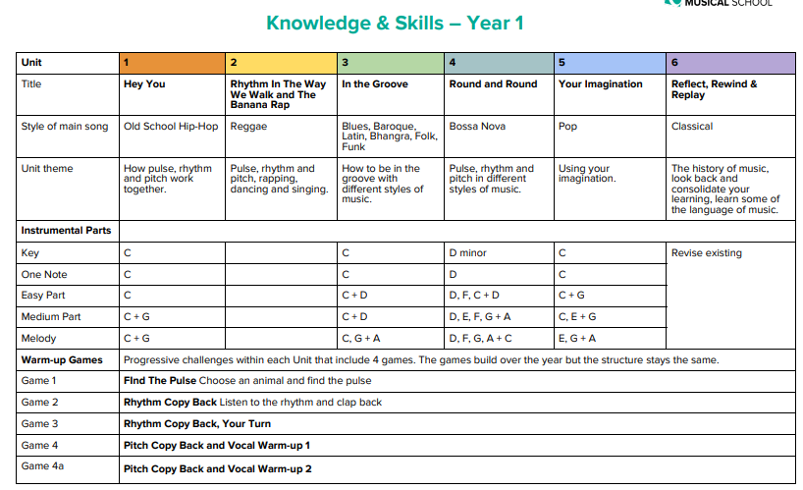
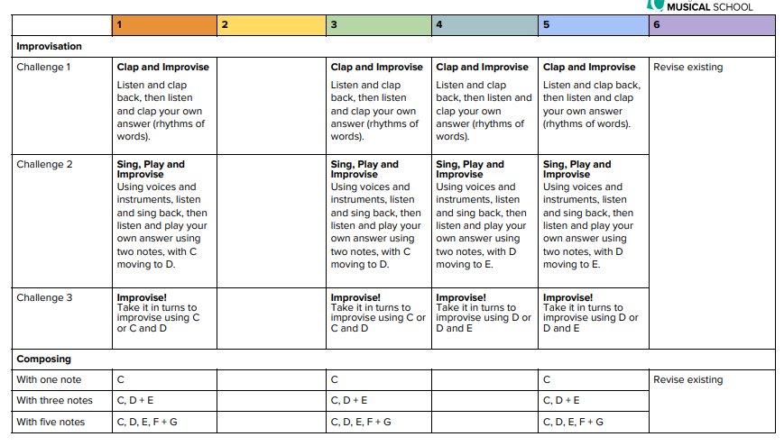

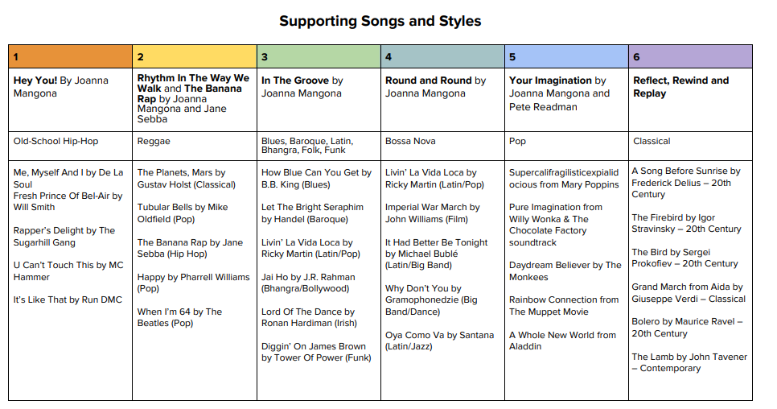

Year 2 Scheme of work
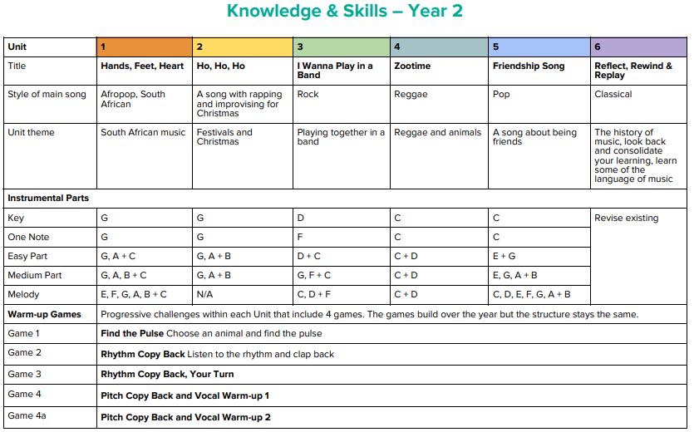
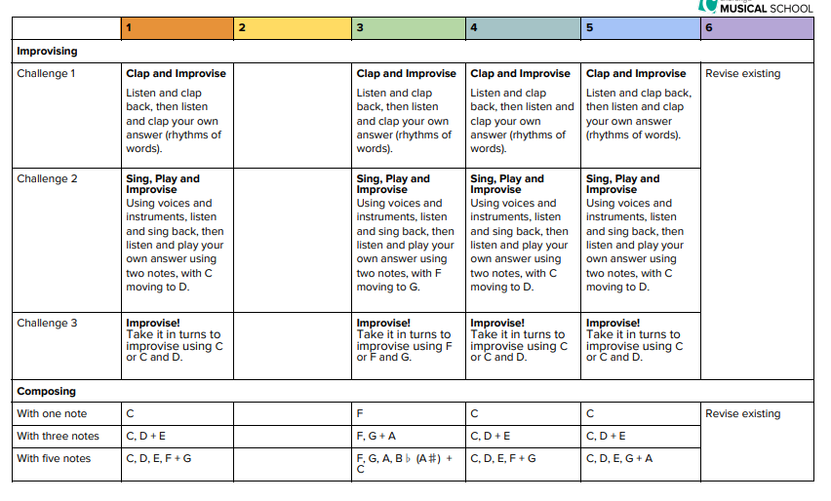
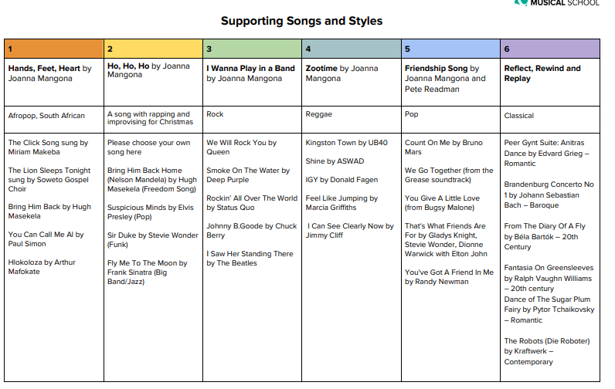

Key KS2 Units of Work
A musically varied selection of units that cover all you need to deliver a modern and exciting music lesson.

Choose a unit that suits the needs of your class or, create your own custom-built Scheme of Work that is personal to your class by selecting a unit for each half term.
A New Year Carol | Blackbird | Bringing Us Together | Classroom Jazz 1 | Classroom Jazz 2
Dancing In The Street | Don't Stop Believin' | Fresh Prince Of Bel Air | Glockenspiel Stage 1 | Glockenspiel Stage 2
Hands, Feet, Heart | Happy | Hey You! | Ho Ho Ho | I'll Be There
Lean On Me | Let Your Spirit Fly | Livin' On A Prayer | Make You Feel My Love | Mamma Mia
Stop! | The Dragon Song | The Fresh Prince Of Bel-Air | Three Little Birds | You've Got A Friend

KS2 Topics
These Topics contain a collection of songs and sometimes related resources. They can be used flexibly to support your teaching and allow learning to be embedded and sythesised.

Ancient Egypt | Animals | Around the World | Celts and Romans | Christmas | Cinderella
Dragons | Dinosaurs | Do You Know...? | Energy | English Folk Songs | Food
Great Composers | Hymns | Mathematics | National Anthems | Oceans, Seas and Rivers | Plastic
Remembrance Day | Science | School | Songs from Scotland | Space | Staying Healthy
Tuning The Tables | Vikings

Year 3
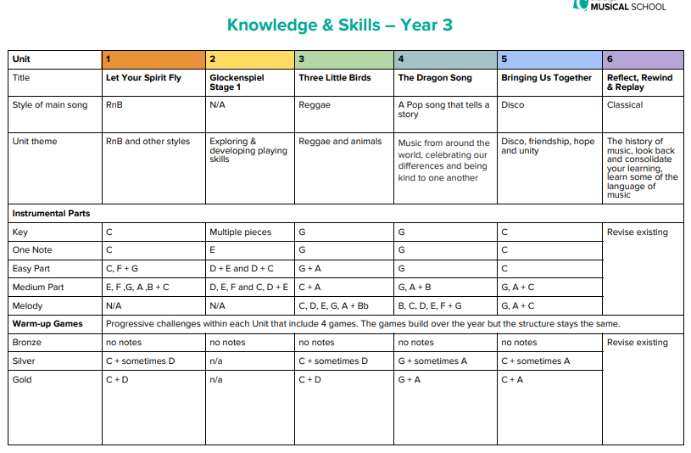
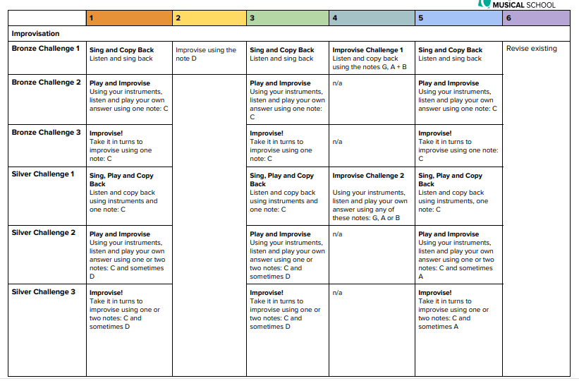
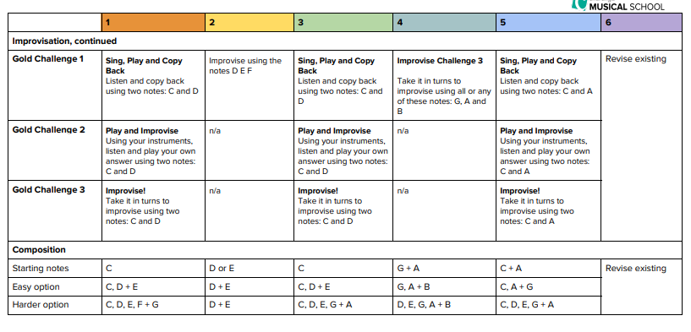
Year 4
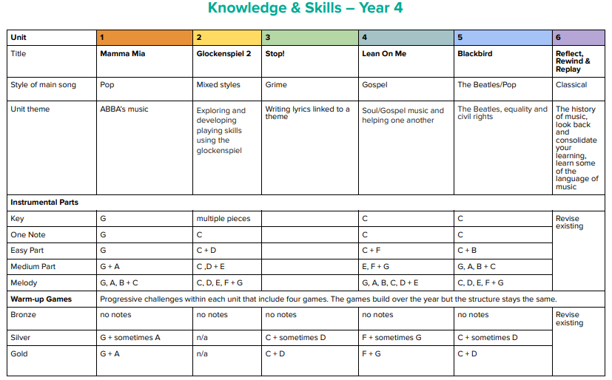
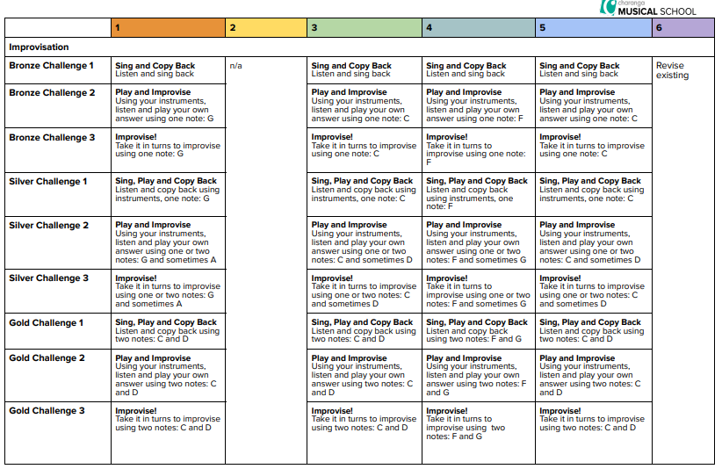
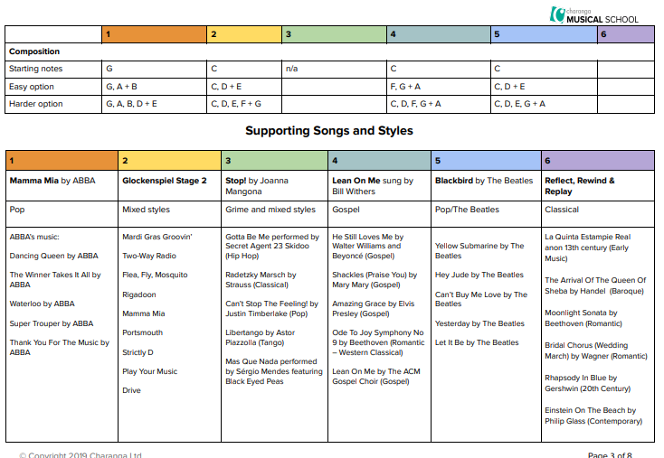

Year 5
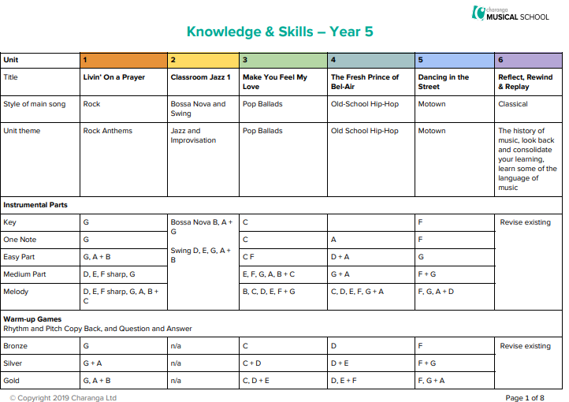
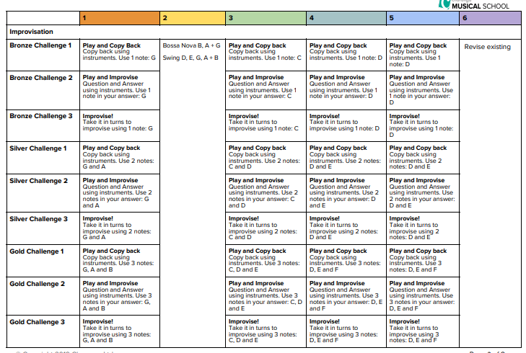
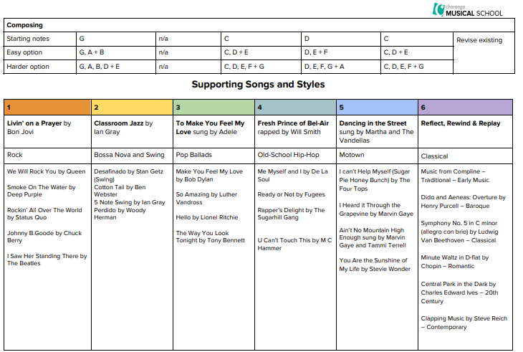

Year 6
